
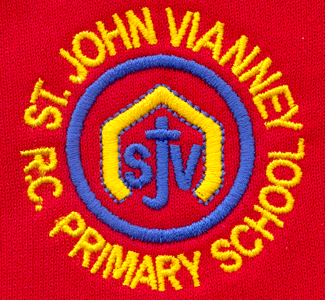

Hillhead Road
West Denton
Newcastle upon Tyne
NE5 1DN
Telephone: 0191 2672233
Fax: 0191 2679538
admin@stjohnvianney.newcastle.sch.uk
www.stjohnvianney.newcastle.sch.uk

Mr A M Duffy
Headteacher
St. John Vianney Catholic Primary School
©

10th September 2019

Dear Parents/Carers,

STAFF TRAINING DAYS 2019/20

School will be closed to pupils on the following dates for staff training:

Monday 23rd September 2019

Friday 19th June 2020

Friday 17th July 2020

A calendar highlighting these dates as well as all of the term dates and school holidays for 2019-20 can be found overleaf.

Yours sincerely,

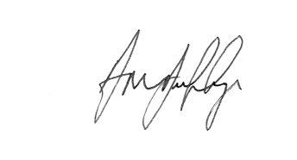

Mr A M Duffy
Headteacher













