


Hillhead Road
West Denton
Newcastle upon Tyne
NE5 1DN
Telephone: 0191 2672233
Fax: 0191 2679538
admin@stjohnvianney.newcastle.sch.uk
www.stjohnvianney.newcastle.sch.uk

Mr A M Duffy
Headteacher
St. John Vianney Catholic Primary School

15/5/2020

Dear Parents and Carers,

You will all be aware of the Government wishes to reopen schools for Nursery, Reception, Year 1 and Year 6 pupils as well as the current provision for vulnerable and key worker’s children by the 1st of June, if possible. That I think would be the aspiration of everyone who wants to get back to the normality of friends, lessons and school life.

However, parents would expect that my first priority is the safety and wellbeing of children and staff and indeed the safety and well-being of parents / carers of our children. To be clear, this virus kills adults and children.

To that end, we are working with the Local Authority, including Public Health England, so that everyone can have confidence in the arrangements for the safe return of our children. Any return to school will need to be phased and gradual, to allow us to test our safety systems.

I will write to you when I have more detail if and when I think this might be possible.

Can I thank you in advance for the kind support and consideration you have offered my staff and I during this unprecedented time.

Yours sincerely,

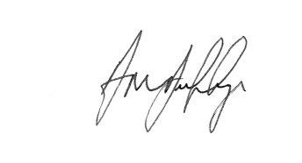
Mr A M Duffy
Headteacher











