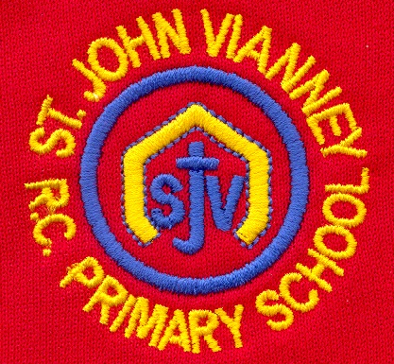

**History**

***The Romans:***

What was the impact of the Roman Empire on Britain?

**Mathematics**

***Calculation:***

* Multiplying 3 digit numbers.
* Dividing 2 and 3 digit numbers.
* Solving word problems.

***Graphs:***

* Drawing and reading graphs including pictograms, bar graphs and line graphs.

***Fractions:***

* Understanding and simplifying mixed numbers.
* Simplifying improper fractions.
* Finding equivalent fractions
* Adding and subtracting fractions.

***Time:***

* 24 hr. clock.
* Converting minutes to seconds and hours to minutes.

**PSHE**

Health and Wellbeing; Relationships; Living in the Wider World.

**Computing**

**Programming:** To use various programs on code.org

**Raspberry Pi:** To set up, customize and use raspberry pi technology.

**Art**

***Formal Elements of Art***

Exploring texture and pattern developing a range of mark-making techniques, making and printing.

**P.E.**

***Gymnastics:*** Supporting and receiving bodyweight.

***Games:*** Agility and Coordination activities such as skipping.

**Science**

***States of Matter:*** To understand and compare solids, liquids and gases. To understand the role of condensation and evaporation in the Water Cycle.

***Sound:*** Identify how sounds are made, how we hear and how sound travels. Understand pitch and amplitude.

**Geography**

**Rivers and Mountains:**

Recognising mountain landscapes in the UK, the features of a mountain, the journey of a river and river landforms.

**Year Four – Spring Term**

**English**

***Exploring Poetic Form:*** Understanding Haiku,

Kennings, Cinquains and Calligrams.

***Folk Tales:*** To explore various Just So Stories written by author, Rudyard Kipling.

***Play Scripts:*** To understand the features of play scripts. To write own play script.

***Persuasive texts:*** Features of persuasive texts and adverts.

***Grammar:***  Including subordinating connectives, fronted adverbial phrases, use of comma, use of speech punctuation.

***Handwriting:*** Continue to use the diagonal and horizontal strokes that are needed to join letters.

***Guided Reading:*** we will read Just So Stories, Bill’s New Frock, Non Fiction books all about the UK and in Performance Poetry we will read, Haiku Poems.

**Religious Education**

***Local Church***

Life in the local Christian community; ministries in the parish

***Eucharist***

Relating – Giving and Receiving- Living in Communion

***Lent/Easter***

Giving: Self Discipline- The family of God in Scripture

***Other Faiths: Islam***

Holy Books- The Qur’An

**Design Technology**

***Structures***

We will investigate a collection of different shell structures including packaging. Use computer aided design (CAD).

**French**

Children will recap months of the year & learn how to say their birthday and ask people their birthdays in French. They will learn French words for weather and discuss the weather in different seasons.

**Music**

Children will begin to learn to play the guitar and they will be introduced to playing the keyboard. They will learn chords and melodies and they will take part in sight reading of notes.