St. John Vianney R.C. Primary School
How to help your child with Reading

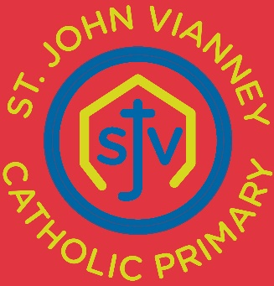

Examples of VIPERS Questions to ask your child
during home-school Reading

Key Stage 1
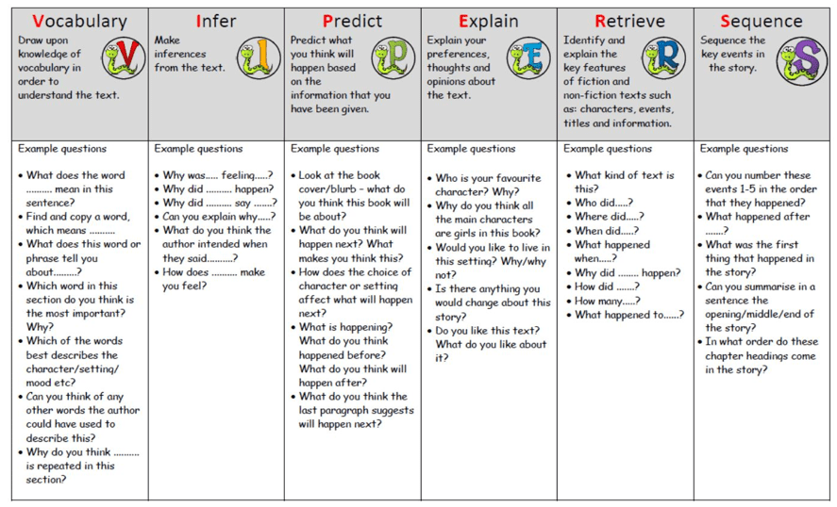

St. John Vianney R.C. Primary School
How to help your child with Reading

Examples of VIPERS Questions to ask your child
during home-school Reading

Key Stage 2
