


Hillhead Road
West Denton
Newcastle upon Tyne
NE5 1DN
Telephone: 0191 2672233
Fax: 0191 2679538
admin@stjohnvianney.newcastle.sch.uk
www.stjohnvianney.newcastle.sch.uk

Mr A M Duffy
Headteacher
St. John Vianney Catholic Primary School
©

4th September, 2019





Mrs Langford Mrs Dunsford Mrs McLean
(Mon/Tues/Wed (Thurs/Fri) (Monday – Friday)

Dear Parents and Carers of Year 1 children,

Now that the children are in Year 1, the way children are dismissed will change from the procedure that you followed in Early Years.

All Year 1 children will be dismissed from the green gates that are situated at the entrance to school, next to the school office. They will come out of the gate and stand in either Bay 1 or Bay 2, whichever Bay is free. Your child’s class teacher will hand over each child on a one-to-one basis to their parent/carer/grandparent etc so please keep a look out for your child coming out of the gate.

To ease the flow of handover, can I please ask that you stand near this area so that children are not handed over to an adult that is situated a distance away.

The children have practised walking out of school this way through the green gate and they are now familiar with this routine.

Thank you for your co-operation in this matter and for your continued support.

Yours sincerely,

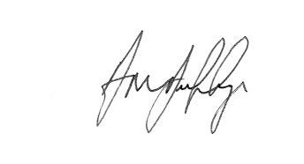

Mr A M Duffy










Headteacher

