
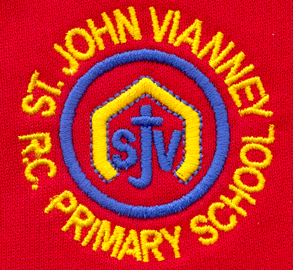

Hillhead Road
West Denton
Newcastle upon Tyne
NE5 1DN
Telephone: 0191 2672233
Fax: 0191 2679538
admin@stjohnvianney.newcastle.sch.uk
www.stjohnvianney.newcastle.sch.uk

Mr A M Duffy
Headteacher
St. John Vianney Catholic Primary School
©

24th May, 2019
Dear Parents and Carers,

Well done Year 6!
Last week, our Year 6 children sat their National SATs tests in school. Every single one of our children tried their very, very best and the Year 6 teaching team (comprising Miss Pawley, Mrs Bury and Mrs Dunn) were extremely proud of every single one of them. Well done Year 6!

PTFA
The next PTFA meeting will take place on Wednesday 19th June at 4.30pm in school. Mrs Meldrum, Miss Cherry and Mrs McDine look forward to seeing as many of you there as possible. You are all extremely welcome.

After-School Clubs
Our After-School clubs will start week commencing 17th June. Please note that, due to events happening in school, these will run for three weeks only next half-term. We will send out these letters as soon as the clubs are finalised so please keep a look out for these.

Training Days
This is a further reminder that we are having two training days this term. As we have already informed you, these are:
Friday 21st June: Staff Training Day - School closed to pupils
Friday 19th July: Staff Training Day – School closed for building preparation enabling works

Gardening Club
Our Gardening Club has been very busy planting and weeding our allotment in school. Mrs Langford would like to thank B&Q for their very kind donations of plants, pots, gardening gloves and seeds. They
have been much appreciated.

Mr Cowen’s 10km Obstacle Race
Mr Cowen and his family are taking part in a 10km Obstacle Race in July in memory of Daniel Hilpert. They will be raising money for CHUF, which is the Hilpert family’s chosen charity. If anyone wishes to donate and support the fantastic work of CHUF, then please go to: www.justgiving.com/fundraising/jonny-cowen. Thank you.

Good News
On Wednesday, our Cross Country team competed in the Catholic Championships at St. Cuthbert’s High school. All of our children who competed were wonderful sporting ambassadors for our school. I must say particular congratulations to Charlie in Year 4, who won the Under 9 category, and this is the first time that our school has won this category for over 22 years! Well done also to Sydney in Year 6, who came a superb 2nd place in her race and Zara in Year 3, who came a brilliant 3rd place in her race. Well done to all of our cross-country team – Miss Cherry was very proud of you all.

Happy Holidays!
This half-term has been an extremely busy term in school and we look forward to another exciting half-term after the holidays. Mrs Meldrum has already written to you all outlining dates for your diary so you can see how alive our curriculum is here at St. John Vianney school. Can I take this opportunity to thank you all for your continued support of our school and wish you all a wonderful holiday. I look forward to welcoming all of our children back to school on Monday 10th June.

Yours sincerely,
Mr A Duffy
Headteacher





