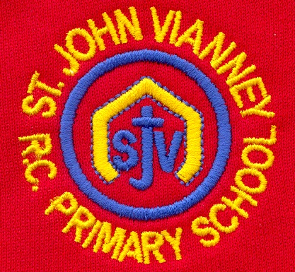

**French**

Children will sequence a story in French (*Toutes les Couleurs*). They will name colours and body parts in French.

**Computing**

Digital trails, algorithms, introduction to coding, programming and debugging.

**PSHE**

**Health and wellbeing, relationships & Living in the Wider World.** Identifying the needs of people, knowing choices have consequences & people’s decisions and circumstances.

**Mathematics**

**Autumn Term revision**

**Arithmetic tests / Times Tables Rock Stars**

***Measurement:*** Use rulers, scales, thermometers and measuring vessels to recognise m / cm, l / ml and g / kg. Tell the time to the nearest 5 minutes. Recognise and use symbols for pounds (£) and pence (p). Combine amounts to make a particular value.

***Shape:*** Properties of 2D and 3D shapes. Read and write shape names. Compare and sort shapes.

***Position and Direction:*** patterns and sequences. Turns, half turns, quarter turns. Clockwise / anti clockwise.

***Statistics:*** read and construct pictograms, block graphs & tally charts. Answer questions using data.

***Place value:*** Use place value and number facts to solve problems. Estimate and identify missing numbers using a number line.

***Developing and Applying calculation:*** Recall addition and subtraction facts to 20 fluently. Add and subtract numbers. Use a blank number line to record calculations.

***Multiplication and Division*:** Recall and use multiplication and division facts for 2, 3 5, and 10 times tables. Count in steps of 2, 3, 5 and 10 from any number forwards and backwards. Recognise odd and even numbers.

**Music**

Children will study Musicianship and they will explore pulse, rhythm, pitch and dynamics. They will play rhythms on percussion instruments and the xylophone.

**P.E. *Games:*** Ball skills, dribbling, kicking and hitting. Team games and rules. Link to different games and sports. **Gymnastics** – floor skills and balance.

**History**

***Famous Kings and Queens:*** Using different sources to find out about the past. Order Kings and Queens on a timeline. Describe, compare and discuss chronologically.

**Art**

**Human Form:** - Exploring how bodies and faces are portrayed in art: looking at works of art, creating collages, drawing portraits, creating a collage. Artists - Hockney / Warhol

**Geography**

***Kenya:*** Contrast and compare Isle of Struay (Katie Morag link) to Kenya.

***World Geography***: Name and locate seven continents and five oceans. Use world maps, globes & Google Earth.

**Design Technology**

Design a healthy wrap / sandwich – learn about food groups to understand a balanced diet to develop a healthy wrap or sandwich.

**Year Two – Spring Term**

**Science**

***Living Things and Habitats:*** Explore and compare differences of objects / items living, dead & never been alive. Life processes MRS GREN movement, respiration, sensitivity, growth, reproduction, excretion & nutrition.

Habitat suitability, naming plants and animals including mini beasts. Understanding food chains.

**English**

***Red Riding Hood:* fiction** –Planning and writing a story with a twist.

***‘Horrid Henry’ by Francesca Simon***

***‘Mr Majeika’ by Humphrey Carpenter***

Characters; letters; discussion & comprehension. Different stories by the same author

***Dictionary Skills:*** Alphabetical order, word meanings and glossary use.

***Poetry: Really looking*** Learning poems off by heart, poetry comprehension.

***SPAG (Spelling Punctuation & Grammar):*** Capital letters and full stops, exclamation marks, speech marks, commas in a sentence, conjunctions & past and present tense. Stage 5 and 6 phonics. Guided / individual reading.

**Religious Education**

***Books***

Bible stories from the New and Old Testament. Exploring The Bible. **Why do we need books?**

***Thanksgiving (Eucharist)***

The Last Supper. Learn about parts of The Mass / responses used by the parish family.

**Why should we be grateful people?**

***Opportunities***

Lent / Easter. The importance of Holy Week.

**How does each day offer opportunities for good?**

***Other Faiths: Islam***

Prayer at home.