
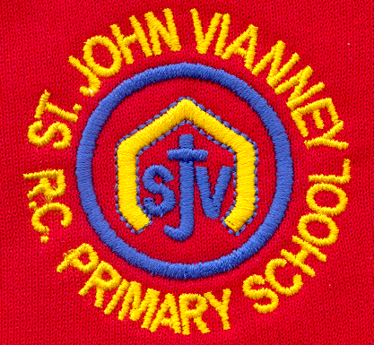

Hillhead Road
West Denton
Newcastle upon Tyne
NE5 1DN
Telephone: 0191 2672233
Fax: 0191 2679538
admin@stjohnvianney.newcastle.sch.uk
www.stjohnvianney.newcastle.sch.uk

Mr A M Duffy
Headteacher
St. John Vianney Catholic Primary School
©

26th November, 2019
Dear Parents and Carers,

Year 3 Advent Service
On Thursday afternoon, our Year 3 children will be leading their families in an Advent Service. This will start at 2.15pm in the school hall. Our PTFA will also be selling raffle tickets. Can I please ask that you bring your tickets along as we really are restricted for numbers this year. Thank you for your co-operation.

Year 4 Advent Service
On Friday afternoon at 2.15pm, our Year 4 children will be leading their families in an Advent Service in the school hall. Please remember to bring your tickets and any spare change for our PTFA raffle!

Children In Need
Can I say a huge thank you to you all for your generous donations for Children In Need. I am delighted to inform you that the children of St. John Vianney school raised £580.94. This is an incredible amount of money, which will go towards helping many children in our region. What an incredible achievement!

First Holy Communion
The next First Holy Communion session will take place on at Thursday 5th December after school.

Christmas Dinner Day – Non-Uniform Day
On Wednesday 4th December, it is Christmas Dinner Day and a non-uniform day. Children are invited to come into school wearing their Christmas jumper as part of their non-uniform if they wish. You will all have received a letter by now from our school office offering children who are packed lunch the opportunity to have Christmas Dinner on this day. If you have not yet received this letter, please call at the school office.

The Travelling Crib
On Monday, we will begin sending home The Travelling Crib once again to enable our children to share the most important Christmas message of all with their families at home. If you would like your child to take part, could you please complete the slip on the attached letter and return it to your child’s class teacher.

The Sun Books for School
We are collecting The Sun Books for Schools tokens. This is an initiative where schools can receive hundreds of pounds of Collins books free! Please send all tokens from The Sun newspaper into school marked for the attention of Mrs Meldrum. Thank you for your continued support of our school.

Yours sincerely,

Mr A M Duffy
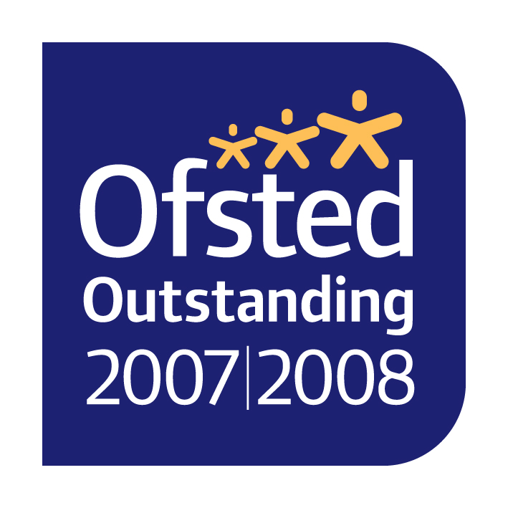
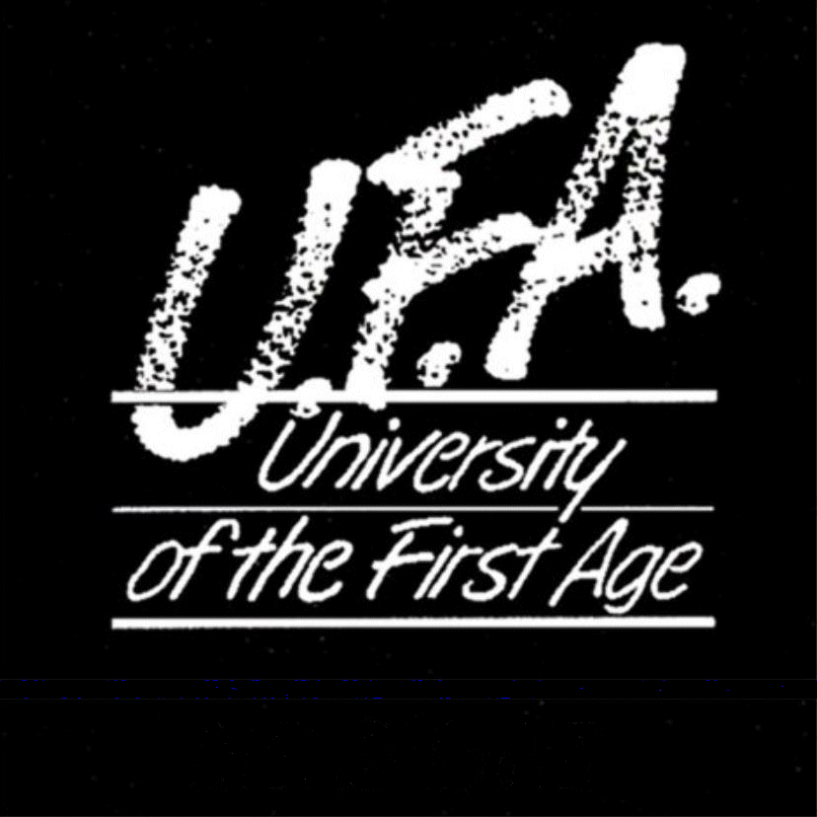
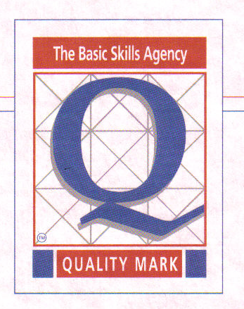

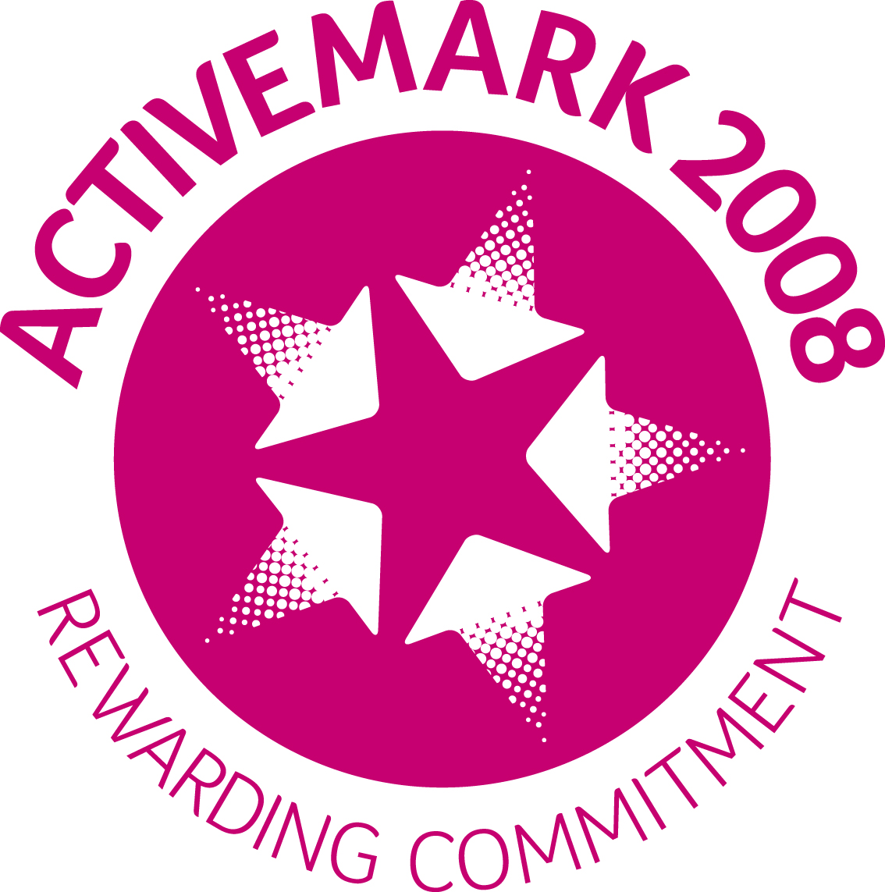
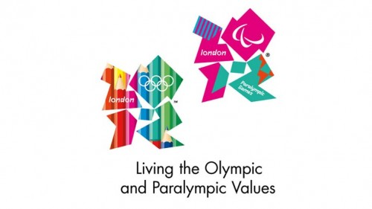
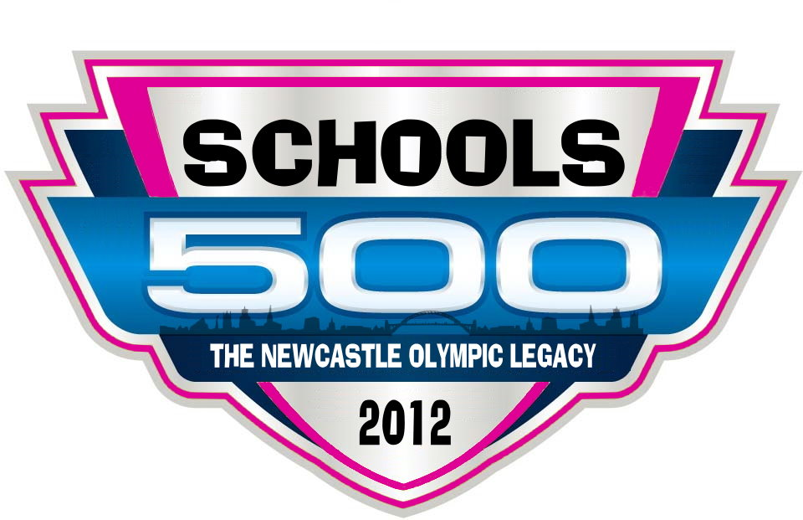

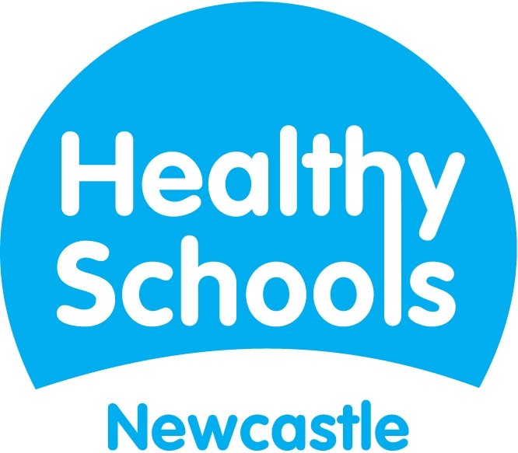
Headteacher

