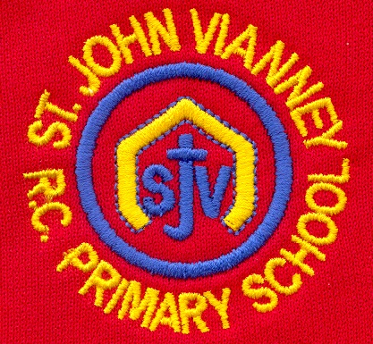

**Computing**

***The Internet:***

To describe what the internet is, why some information may not be accurate. Differences between a website and a webpage.

**Mathematics**

***Decimals –*** Writing tenths and hundredths; Dividing by 10s and 100s; Rounding decimals; Writing fractions as decimals.

***Money –*** Writing, comparing and rounding amounts of money.

***Length, Mass and Volume –*** Converting units of length, mass and volume; Estimating length, mass and volume; Comparing and ordering measurements.

***Area and perimeter –*** Understanding area and perimeter; Measuring perimeter of figures, squares and rectangles.

***Geometry –*** Comparing angles; Classifying triangles; Identifying symmetrical figures; Identifying lines of symmetry; Comparing and classifying shapes.

***Position and movement –*** Describing position; Plotting points; Describing translations.

***Roman Numerals –*** Writing Roman numerals.

**History**

***The Romans:***

What was the impact of the Roman Empire on Britain?

**Science**

***Sound:*** Identify how sounds are made, how we hear and how sound travels. Understand pitch and amplitude.

***Habitats:*** To understand the seven life processes. To understand what a habitat is and what animals/plants need to survive. To identify different habitats. To investigate animals preferred habitats.

**Year Four – Summer Term**

**Design Technology**

Work in groups to adapt an existing biscuit recipe, whilst taking into account the cost of the ingredients and other expenses against a set budget.

**Art**

**Sculpture:**

Making Maracas from Recycled Materials

Making Drums from Recycling

Work inspired by Arcimboldo and Sokari Douglas Camp

**Religious Education**

***Pentecost***

Serving: New life –The new life of the Easter message is spread through the power of the Holy Spirit.

***Baptism/Confirmation***

Belonging: Called- Through Baptism and Confirmation people are given the gift of the Holy Spirit and are called to respond in their lives.

***Universal Church***

*World: God’s People****-*** *Different saints show people what God is like*

***Other Faiths: Islam***

Holy Books- The Qur’An

**Geography**

**Resources and Trade:**

Food around the world

Minerals around the world

Who do we trade with?

Trading in the future

**English**

***Narrative:*** To write a story based around our guided reading text ‘Max and the Millions’.

***Issues and Dilemmas:*** We are reading Bill’s New Frock for this topic.

***Classic Narrative Poetry:***

***Grammar:*** To understand and use direct speech, fronted adverbials andapostrophe for possession.

***Explanation Texts:*** To understand the features of explanation texts and Wallace & Gromit’s ‘Crackin’ Contraptions’

***Handwriting:*** Continue to use the diagonal and horizontal strokes that are needed to join letters.

***Guided Reading:*** We are reading Max and the Millions by Ross Montgomery, and Bill’s New Frock by Anne Fine.

**Music**

The children will write crotchets, quavers and minims. They will create simple compositions using times signatures. They will write compositions, which they will then perform as an ensemble.

**PSHE**

*Health and Well-being*

Relationships

Living in the wider world

**P.E.**

***Outdoor Games:*** Play competitive games such as hockey, Tag Rugby, Football, basketball. Apply basic principles suitable for attacking and defending.

**French**

Talk about likes and dislikes. To learn how to replace a noun with the correct pronoun.