
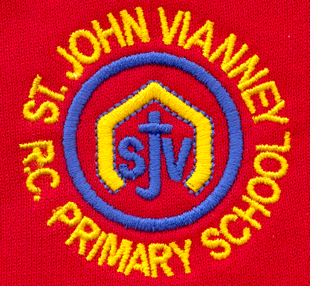

Hillhead Road
West Denton
Newcastle upon Tyne
NE5 1DN
Telephone: 0191 2672233
Fax: 0191 2679538
admin@stjohnvianney.newcastle.sch.uk
www.stjohnvianney.newcastle.sch.uk

Mr A M Duffy
Headteacher
St. John Vianney Catholic Primary School
©

7th January, 2020
Dear Parents and Carers,

This is just a reminder of the arrangements for the SACRAMENT OF FIRST RECONCILIATION.

The celebration will be held in St John Vianney Church on Thursday 16th January at 5.00 p.m.

Children should arrive at church with their families no later than 4.50 p.m.

This is an important step on your child’s faith journey and we are looking forward to celebrating this Sacrament with all of the children and their parents and carers in attendance.

All children are required to wear their full school uniform.

Children will sit together as a class at the front of church with their class teacher and their families may sit in any available space within the church.

After the Penitential Reflection, the children will be invited to go up one at a time to make their Reconciliation. They will then return to their place at the front of church. During this time of quiet reflection, some hymns will be sung and we ask that all family members observe this time of silence as well as joining in with the singing as much as possible.

The children will say their Act of Contrition together after each child has made their Reconciliation.

The service will end with a prayer and blessing.

If you have any further queries, please do not hesitate to contact me.

Yours sincerely,

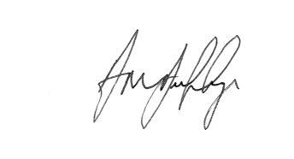
Mr A M Duffy
Headteacher












