
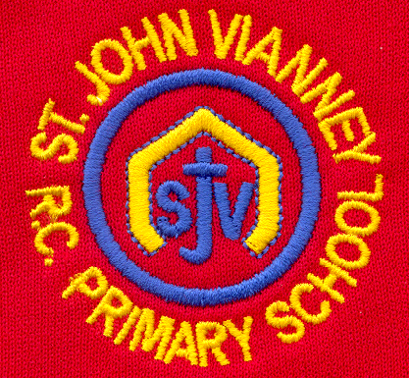

Hillhead Road
West Denton
Newcastle upon Tyne
NE5 1DN
Telephone: 0191 2672233
Fax: 0191 2679538
admin@stjohnvianney.newcastle.sch.uk
www.stjohnvianney.newcastle.sch.uk

Mr A M Duffy
Headteacher
St. John Vianney Catholic Primary School
©

27th June, 2019
Dear Parents and Carers,

Class Liturgies
I would like to say a big thank you to everyone who came and supported Miss Prayle’s Year 2 Class Liturgy on Tuesday morning and Mr Cowen’s Reception Class Liturgy on Wednesday morning. Both classes led their families, friends and members of the parish community in two wonderful Liturgies. All of the children read beautifully and they sang their hearts out! This was a lovely way to start each day and another wonderful example of the strong home-school-parish links that we have here at St. John Vianney school. Well done and thank you to everyone involved.
Mrs Duffy’s Reception children would like to invite their parents/carers and friends to their Class Liturgy on Wednesday morning at 9.15am in the school hall. We look forward to seeing you there.

Class Trips
Our Year 4 children enjoyed a super day at Vindolanda and the Roman Army Museum on Wednesday. A great day was had by all!
Next week, we have a number of school visits taking place. Year 3 will be visiting the Oriental Museum in Durham on Monday, Year 1 will be visiting Alnwick Castle on Tuesday, Year 5 are taking part in a Residential visit to Kingswood Activity Centre next week and our Year 6 children will be visiting their new schools on Wednesday and Friday. You will all have received letters and forms to complete from your child’s class teacher about these events. Let’s hope the sun shines on all of our children next week!

Key Stage 1 Performance
Next week, our Key Stage 1 pupils will perform Aesop’s Fables for Year 1 parents/carers on Wednesday at 2.15pm and for Year 2 parents/carers on Thursday at 2.15pm. They have been working very hard in preparation for this and we know they will fabulous. Good luck everyone!

Thank you for your continued support of our school.

Yours sincerely,
Mr A Duffy
Headteacher












