
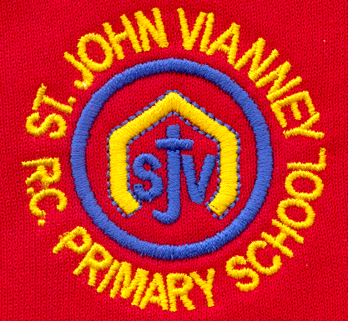

Hillhead Road
West Denton
Newcastle upon Tyne
NE5 1DN
Telephone: 0191 2672233
Fax: 0191 2679538
admin@stjohnvianney.newcastle.sch.uk
www.stjohnvianney.newcastle.sch.uk

Mr A M Duffy
Headteacher
St. John Vianney Catholic Primary School
©

4th November, 2019
Dear Parents and Carers,

Welcome Back!
Welcome back! I hope you have had a lovely half-term holiday and that the children are ready for another busy but exciting term in school.

Home-School Reading Books
Mrs Meldrum and Mrs Duffy, our English Co-ordinators, are in the process of re-organising and cataloguing our home-school Reading books since we have recently ordered nearly £5,000.00 of new reading books, which will arrive in school this week. They have also re-organised the books so that they now match more closely the sets of phonic words and sounds in the order that we teach in class. Can I therefore please ask that any home-school Reading books that you have at home are returned to school as soon as possible to help them carry out this task. There will, therefore, be no home-school Reading books sent home this week. Your child will continue to bring home their home-school Reading books next week as normal. Thank you in advance for your co-operation.

PTFA Fashion Show
I must say a HUGE thank you to our wonderful PTFA for organising a very successful Fashion Show on Saturday in order to raise funds for our children. There was a lot of hard work went into the organisation and production of the Fashion Show from our PTFA and it was very well-attended by our parents and carers. Thank you to everyone who came along and supported this event and who managed to get some bargains in the process! Your support is, as always, much appreciated.

Cauliflower Cards
Today was the last day for handing Cauliflower Card forms into school as they are being collected first thing tomorrow morning. You can still order from the Cauliflower Cards website but you will need to pay delivery. Thank you to everyone who has supported us. School receives a monetary donation for every pack of cards sold so this is a wonderful way of fundraising for our school.

After-School Clubs
Due to the inclement weather that is expected this term and the fact that a number of Nativity productions will most likely take place in our school hall at the end of November and throughout December, there will be no JJ Sports after-school clubs this term since we are currently operating with only part of our school hall. LEGO Club for Year 3, which takes place in a classroom, and Gary Ives football for Years 1-6, which takes place outside on our football pitch, will run as normal. Thank you, once again, for your co-operation during this last phase of our building work.

Hair Styles
Can I please remind you of our uniform policy with regards to hair styles:
“We ask that parents support the school in encouraging children to moderate their choice of hair styles. We would hope that children are identified for their personal qualities, academic effort and indeed all round general ability rather than how they look. Therefore, styles such as tram lines, short/shaven hair with pony tails are not encouraged. Could we also remind parents that children with long hair should ensure that it is tied back during the school day.”
Thank you to the vast majority of our parents and carers, who do support us in our uniform policy.

Mini Vinnies Meeting on 11th November
The next Mini Vinnies meeting will take place next Monday, 11th November, from 3.15pm – 4.15pm.
Our Mini Vinnies will be tasked with the job of organising our Travelling Nativity bags, which we will be sending out again this year during Advent. This was very well-received last year and we look forward to our children sharing the real message of Christmas at home again with their families this year.

Thank you for your continued support of our school.

Yours sincerely,
Mr A M Duffy
Headteacher





