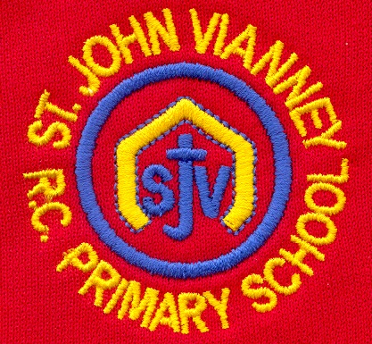

**Design Technology**

**Food:** Explore where our food comes from; understand the principles of healthy and varied diets; design a healthy lunch box.

**P.E.**

**Games:**

Develop a range of fundamental movement skills including running, jumping, throwing, hitting and catching in isolation before applying such skills to game related situations.

**Art**

**Art and Design Skills:** Develop drawing, design, craft and art appreciation skills; explore two different printing techniques, use 2D shapes to explore a variety of media, mix different shades of one colour and discuss the work of artist Louis Wain.

**Computing**

**Creating Media – Digital Media:**

Develop an understanding of word processing and develop keyboard skills.

**Music**

Children will study Musicianship and they will explore pulse, rhythm, pitch and dynamics. They will learn to play rhythms on percussion instruments and the xylophone.

**PSHE**

Health and Wellbeing; Living in the World; Relationships.

**English**

**‘I Want My Hat Back’**

Compose a sentence orally before writing it; predict what might happen next in a story; use a collection of adjectives in writing.

**‘Bubbles’ (animated tale)**

Sequence sentences to form short narratives; join words and clauses using ‘and’; continue to use capital letters, finger spaces and full stops to punctuate sentences.

**‘Mama Panya’s Pancakes’**

Explore stories from other cultures; reread sentences to check they make sense.

**Non-fiction:** Read, explore and write basic information texts; write a non-chronological report about George Stephenson.

**Poetry:** Recite poems by heart.

**Phonics:** Phase 5 Letters and Sounds

**Science**

**Everyday Materials:** Identify and name a variety of everyday materials, including wood, plastic, glass, metal and fabric.

**Animals:** Name the main parts of the body; explore the senses; recognise that there are different kinds of animals.

**Religious Education**

**Special People**

There are special people in our lives who are there to help us.

**Meals**

The Last Supper was Jesus’ special meal.

**Change**

Lent is a time to change in preparation for the celebration of Easter.

**Year One – Spring Term**

**Geography**

**The UK:** Explore the four countries of the United Kingdom and their capital cities; begin to recognise the four directional points on a compass; distinguish between cities, villages, coastal and rural areas.

**Mathematics**

**Place value:** Count up to 100, forwards and backwards, beginning with 0 or 1, or from any given number; identify one more and one less than a given number; compare and order numbers and quantities.

**Calculation:** Recognise and use number bonds and related subtraction facts within 20; add and subtract one-digit and two-digit numbers to 20; group and share small quantities.

**Measurement:** Tell the time to the hour and half past the hour.

**Geometry:** Describe position, direction and movement, including half, quarter and three-quarter turns.

**History**

**George Stephenson:** Create a timeline of events to show how transport has changed; explore the life of George Stephenson, his achievements and his links to the North East.