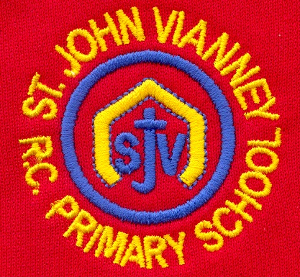

**Geography**

**My Local Area:** Distinguish between cities, towns and villages; think about things that are near and far away from where we live; walk around our local area; creating a map of our school.

**Design Technology**

**Food:** Explore where our food comes from; understand the principles of healthy and varied diets; design a healthy lunch box; taste and try new fruits and vegetables; make a healthy snack.

**P.E.**

**Games:** Develop a range of fundamental movement skills including running, jumping, throwing, hitting and catching in isolation before applying such skills to game related situations.

**Computing**

**Creating Media – Digital Media:**

Develop an understanding of word processing and develop keyboard skills.

**Music**

Children will start to develop a critical ear when listening to recorded and live music. They will investigate the instruments of the orchestra and be able to identify them by sight - and also some by sound.

**Science**

**Everyday Materials:** Identify and name a variety of everyday materials, including wood, plastic, glass, metal and fabric.

**PSHE**

Health and Wellbeing; Bad secrets; Friendships and Relationships; Exercise; Money, real life choices.

**History**

**Women in History:** Create a timeline of a historical figures life, explore why they are famous, how they changed the future for others.

**Mathematics**

**Height and Length:** Comparing and measuring the height and length of objects using things and a ruler.

**Numbers to 40:** Counting and writing numbers to 40; counting in 10s and 1s; finding more and less than.

**Addition and subtraction:** Solving word problems.

**Multiplication:** Making equal groups and rows; adding equal groups and rows; making doubles.

**Division:** grouping equally and sharing equally.

**Religious Education**

**Special People**

There are special people in our lives who are there to help us.

**Meals**

The Last Supper was Jesus’ special meal.

**Change**

Lent is a time to change in preparation for the celebration of Easter.

**Year One – Spring Term**

**English**

**‘The Colour Monster’**

Compose a sentence orally before writing it; join words and clauses using ‘and’; re=visiting adjectives to describe.

**‘I Want My Hat Back’**

Use a collection of adjectives in writing and group them by type; use drama to explore a characters feelings; continue to use capital letters, finger spaces and full stops to punctuate sentences.

**Non-fiction:** Read, explore and write basic information texts; write a non-chronological report about George Stephenson.

**Poetry:** Recite poems by heart.

**Phonics:** Phase 5 Unlocking Letters & Sounds.