


Hillhead Road
West Denton
Newcastle upon Tyne
NE5 1DN
Telephone: 0191 2672233
Fax: 0191 2679538
admin@stjohnvianney.newcastle.sch.uk
www.stjohnvianney.newcastle.sch.uk

Mr A M Duffy
Headteacher
St. John Vianney Catholic Primary School
©

13th June 2019

Dear Parents of Year 5

Kingswood Dukeshouse Wood Visit – Parents Meeting

A meeting to discuss the arrangements for Dukeshouse Wood activity centre has been arranged for Wednesday 26th June at 4.00pm in school.
This will give an outline of the activities and arrangements for the forthcoming visit in July. We hope you are able to attend.

Could you also complete and return the attached EV7 form for the visit as soon as possible please.

Yours sincerely,

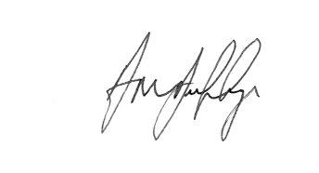

Mr A M Duffy
Headteacher











