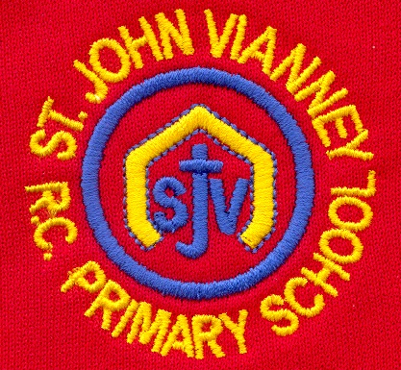

**P.E.**

***Gymnastics:*** gymnastic sequences; using apparatus; travel; speed; positioning

**Music**

Children will begin to play the guitar and keyboard and they will read rhythms and musical notes. They will perform and improvise pieces of music individually and as an ensemble.

**French**

Children will learn how to describe the town in which they live, places in the town and they will ask directions to places in town and give directions.

**PSHE**

Health and Wellbeing; Relationships; Living in the Wider World

**Religious Education**

**Local Church: Sources**

The Bible and its books and authors

**Eucharist: Relating – Unity**

The Eucharist challenges and enables the Christian family to live and grow in communion every day

**Lent: Easter**

The Church’s seasons of Lent, Holy Week and Easter; the suffering, death and resurrection of Jesus led to newlife

**Other Faiths: Islam**

Guidance for Muslims: The 5 Pillars and Zakat

**Mathematics**

***Place value***; ***Calculation; Fractions, Decimals and Percentages***

***Measurement***: Weight, capacity & volume; length & time; money

***Geometry and Statistics:*** Position & direction; properties of shapes; angles

***Position and Direction:*** coordinates on all four quadrants; translation and reflection; compass points

***Algebra:*** formulae; linear number sequences; missing numbers; pairs of numbers to satisfy equations; finding all possible solutions

***Statistics:*** pie charts; drawing and interpreting graphs; miles to km; mean as an average; Venn and Carroll diagrams

**Science**

***Light:*** Light sources; shadows; how light travels;using mirrors; different materials and light; practical investigations.

***Electricity:*** what is electricity;electrical circuits; electrical resistance; testing circuits; practical investigations

**History**

***World War Two (continued):*** key events, key figures; causes; propaganda; children in the war; the Blitz; evacuation; effects; analysing sources

**English**

***‘The Diary of Anne Frank’:*** Biography and autobiography

***‘Letters From The Lighthouse’ by Emma Carroll:*** Diary entry; Letter; Newspaper article; Persuasive speech; narrative

***‘Oliver Twist’ by Charles Dickens:*** Character description; Formal police report; classic narrative

***Persuasive Writing:*** Holiday brochures; campaigns linked to current climate issues

***Grammar:*** revision of Autumn Term grammar; parenthesis; subjunctive form; prefixes/suffixes; hyphens; apostrophes; conjunctions; semi-colons; tenses

**Computing**

***Programming:*** introducing variables; variables in programming; improving a game; designing a game; design to code; improving and sharing

**Art and Design Technology**

***Making My Voice Heard:*** graffiti art; Kathe Kollwitz; Pablo Picasso; clay sculpture

**Geography**

***Rainforests and Ecosystems:*** naming and locating ecosystems; define and describe ecosystems; understand human use of the rainforest and its future; human and physical geography of rainforests

**Year Six – Spring Term**