
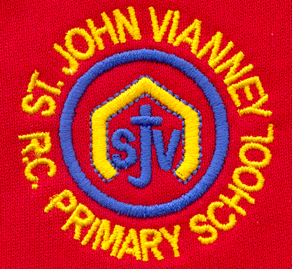

Hillhead Road
West Denton
Newcastle upon Tyne
NE5 1DN
Telephone: 0191 2672233
Fax: 0191 2679538
admin@stjohnvianney.newcastle.sch.uk
www.stjohnvianney.newcastle.sch.uk

Mr A M Duffy
Headteacher
St. John Vianney Catholic Primary School
©

8th March, 2019
Dear Parents and Carers,

The Appointment of Assistant Headteacher – Miss J. Cherry
As Chair of Governors of St. John Vianney Primary school, I am delighted to inform you that Miss Cherry has been appointed the new Assistant Headteacher of St. John Vianney. Miss Cherry has been an outstanding teacher here at our school for over 17 years and we wish her all the very best in her new role.

The Management Structure of the school will be:

Mr Duffy – Headteacher

Mrs Meldrum – Deputy Headteacher

Miss Cherry – Assistant Headteacher

Miss Pawley Mrs Bury / Mrs Watanabe Miss Prayle
KS2 Co-ordinator SENCO RE Co-ordinator

Mr H. Bell
Chair of Governors

World Book Day
We had a fabulous day in school yesterday celebrating World Book Day. The theme of the day this year was ‘Share A Story Today and Every Day’. Mrs Meldrum began the day with an interactive Assembly for the whole school and a series of delightful activities followed in classes. The children particularly enjoyed Reading with their Buddies and the session, ‘Cookie with a Bookie’ was also very well received! I must thank Sainsburys, who donated the cookies for this activity, and to our cook, Mrs Delaney, who cooked individual cookies for all of our children with food allergies. It was also lovely that Mrs Kaluza, our Vice-Chair of Governors and former Librarian, came and read favourite books with our children in KS1. I must say a big thank you to you all for supporting us in this event – the costumes were absolutely magnificent and your voluntary donations are very much appreciated. The children really did celebrate their love of Reading in a fabulous way. Thank you to everyone for your support.

Year 1 Liturgy
On Wednesday morning (13th March), Mrs Langford and Mrs Dunsford’s Year 1 class would like to invite their parents/carers and families to their Class Liturgy. This will take place at 9.15am in the school hall. We look forward to seeing you then.

Year 3 Trip to Pizza Express
On Tuesday, Mr Galley’s Y3 class had a wonderful trip to Pizza Express to support the work they are doing in Design Technology this term. The pizzas they brought back to school smelt absolutely delicious!

Red Nose Day – Friday 15th March
Next Friday is Red Nose Day. We are inviting the children to come into school in their own clothes and wearing something Red. All voluntary donations received will go to Comic Relief.

PTFA Meeting
The next PTFA meeting will take place on Wednesday (13th March) at 4.30pm in school. We are always looking for new recruits so, if you are interested, please come along and find out a little bit more about the work of the PTFA in school.

Thank you for your continued support of our school.

Yours sincerely,
Mr A M Duffy
Headteacher











