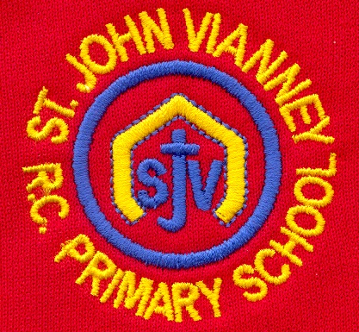

**Music**

**Art**

Investigating the built environment, drawing from observation and evaluating design features of buildings. Children explore a famous architecture, developing ideas to create their own individual vision for a unique space.

**Geography**

**Energy:** investigate energy use; renewable

energy; non-renewable energy; conserving

energy; sustainability; energy for the future

**French**

places in a town (feminine nouns); revise genders of nouns; time on quarter past the hour; world cities; agreement of adjectives with feminine nouns; ordinal numbers

**Computing: Programming**

Follow the algorithm; swimming fish with Sprite lab; Alien dance party with Sprite lab; mini-project: about me; drawing with loops; fancy shapes using nested loops; mini-project: design a snowflake; songwriting; functions in Minecraft; functions with artist

**PSHE**

Health and Wellbeing; Relationships; Living in the Wider World.

**Mathematics**

***Graphs:*** Reading tables; reading line graphs

***Fractions, Decimals and Percentages:***

Dividing to make fractions; writing improper fractions and mixed numbers. Finding equivalent fractions; mixed numbers; improper fractions. Adding and subtracting fractions. Multiplying whole numbers by proper fractions; multiplying proper and mixed number fractions by whole numbers. Read, write, order and compare decimals; adding and subtracting decimals, rounding decimals. Comparing quantities; finding percentages.

**Geometry:**

Know types of Angles; measuring angles; drawing lines and angles. Investigating and solving problems involving angles. Investigating regular polygons. Naming and plotting points; describing translations and movements; successive reflections.

**History *Anglo Saxons and Scots***

Children will have an understanding of who the Anglo-Saxons were and why they invaded Britain and settled there. They will understand how Christianity arrived in England and the significance of certain individuals and places of heritage. Children will discover that many changes took place in the North East of England for the Anglo-Saxons during their time.

**English**

***‘Malamander’ by Thomas Taylor*** Narrative; setting description; letters; instructions; dialogue; newspaper report

***‘The Matchbox Diary’ by Paul Fleischman***

Diary entry; letters; explanation text

***Poetry:* Poems with figurative language**

Poems by Joseph Coelho

***Grammar:*** Relative clauses beginning with who, which, where, when, whose,

Modal verbs – might, should, will, must

Linking across paragraphs using adverbials of time e.g. Later/time, nearby/place, secondly/number or tense choice

Brackets, dashes, commas to indicate parenthesis

**Guided reading –** weekly VIPERS sessions

**Year Five – Spring Term**

**Science**

***Earth and Space***

Describe the movement of the Earth, and other planets, relative to the Sun in the solar system

Describe the movement of the Moon relative to the Earth

Describe the Sun, Earth and Moon as approximately spherical bodies

Use the idea of the Earth’s rotation to explain day and night and the apparent movement of the sun across the sky.

*Working scientifically:*

Identifying scientific evidence that has been used to support or refute ideas or arguments.

Taking measurements, using a range of scientific equipment, with increasing accuracy and precision, taking repeat readings.

**PE**

Dance; Outdoor and Adventurous; Counter balance; floor balance

**Religious Education**

**Local Church - Community*: Mission***

Continuing Jesus’ mission in diocese (ecumenism)

**Eucharist - Relating: *Memorial Sacrifice***

Eucharist as the living memorial of Christ’s sacrifice

**Lent/Easter – GIVING: *Sacrifice***

Lent: a time of aligning with the sacrifice

***Other Faiths:*** **Islam**

Beliefs and festivals – Ramadan and Pilgrimage