


Hillhead Road
West Denton
Newcastle upon Tyne
NE5 1DN
Telephone: 0191 2672233
Fax: 0191 2679538
admin@stjohnvianney.newcastle.sch.uk
www.stjohnvianney.newcastle.sch.uk

Mr A M Duffy
Headteacher
St. John Vianney Catholic Primary School
©

16th July, 2020

Dear Parents and Carers,

As we near the end of this academic year and my final days as Headteacher of St. John Vianney R.C. Primary school, I would like to thank you all for your wonderful support over these past twenty years. It has been my absolute pleasure and privilege to have served the community as Headteacher and work with so many dedicated, talented and inspirational staff and pupils. I wish every one of them every success for the future. I am sure you will support Mrs Meldrum in her role as Acting Headteacher in September. I know she will lead the school confidently through the challenges that undoubtedly lie ahead.

I wish all of our Year 6 children much happiness and success as they move on to their next school in September. I am sure all of the children leaving us will thrive and we wish them good luck as they embark on the next part of their learning journey.

Thank you to all of our wonderful staff for their hard work and commitment to the children throughout the years. Thank you also to all of the families and Governors for the kind words and support that we have received during this term. It has been very much appreciated by all.

I wish you all a safe, healthy and happy Summer and thank you sincerely for twenty wonderful years.

God bless.

Yours sincerely,
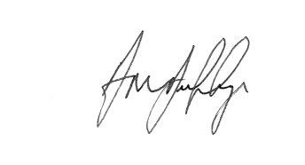
Headteacher

