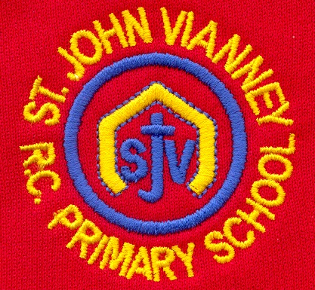

**P.E.**

***Athletics:*** Sprinting techniques / relay skills and baton handover.

***Games:*** Attack and Defending skills. Varied tactics in games.

**History**

***The Romans:***

What was the impact of the Roman Empire on Britain?

**Mathematics**

***Calculation:***

* Multiplying 3 digit numbers.
* Dividing 2 and 3 digit numbers.
* Solving word problems.

***Graphs:***

* Drawing and reading graphs including pictograms, bar graphs and line graphs.

***Fractions:***

* Understanding and simplifying mixed numbers.
* Simplifying improper fractions.
* Finding equivalent fractions
* Adding and subtracting fractions.

***Time:***

* 24 hr. clock.
* Converting minutes to seconds and hours to minutes.

**PSHE**

Health and Wellbeing; Relationships; Living in the Wider World.

**Computing**

**Programming:** To use various programs on code.org

**Raspberry Pi:** To set up, customize and use raspberry pi technology.

**Art**

***Formal Elements of Art***

Exploring texture and pattern developing a range of mark-making techniques, making and printing.

**Science**

***States of Matter:*** To understand and compare solids, liquids and gases. To understand the role of condensation and evaporation in the Water Cycle.

***Sound:*** Identify how sounds are made, how we hear and how sound travels. Understand pitch and amplitude.

**Geography**

**Rivers and Mountains:**

Recognising mountain landscapes in the UK, the features of a mountain, the journey of a river and river landforms.

**Year Four – Spring Term**

**English**

***Exploring Poetic Form:*** Understanding Haiku,

Kennings, Cinquains and Calligrams.

***Myths and Legends:*** Beowulf.

***Folk Tales:*** To explore various Just So Stories written by author, Rudyard Kipling.

***Persuasive texts:*** Features of persuasive texts and adverts.

***Guided Reading:*** we will read Just So Stories, Bill’s New Frock, Non Fiction books all about the UK and in Performance Poetry we will read, Haiku Poems.

**Religious Education**

***Local Church***

Life in the local Christian community; ministries in the parish

***Eucharist***

Relating – Giving and Receiving- Living in Communion

***Lent/Easter***

Giving: Self Discipline- The family of God in Scripture

***Other Faiths: Islam***

Holy Books- The Qur’An

**Design Technology**

***Structures***

We will investigate a collection of different shell structures including packaging. Use computer aided design (CAD).

**French**

Children will look at how to change the endings of adjectives to make them agree with different nouns. They will continue to extend their writing in French using adverbial phrases. They will explore different places in and around Paris.

**Music**

Children will critically analyse live and recorded music using increasingly complex musical language. They will identify the instruments heard, investigate the form and structure of the pieces and give their opinions of the music. Children will sing complex partner songs and rounds. Children will continue to develop their music reading and writing.