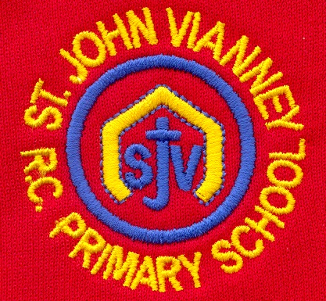

**Music**

Children will study Musicianship and they will explore pulse, rhythm, pitch and dynamics. They will learn to play rhythms on percussion instruments and they will play as part of an ensemble.

**P.E.**

**Games:** Develop a range of fundamental movement skills including running, jumping, throwing, hitting and catching in isolation before applying such skills to game related situations.

**PSHE**

Health and Wellbeing; Bad secrets; Friendships and Relationships; Exercise; Money, real life choices.

**Design Technology**

**Food:** Explore where our food comes from; understand the principles of healthy and varied diets; design a healthy lunch box; taste and try new fruits and vegetables; make a healthy snack.

**Geography**

**My Local Area:** Distinguish between cities, towns and villages; think about things that are near and far away from where we live; walk around our local area; creating a map of our school.

**Computing**

**Creating Media – Digital Media:**

Develop an understanding of word processing and develop keyboard skills.

**Science**

**Everyday Materials:** Identify and name a variety of everyday materials, including wood, plastic, glass, metal and fabric.

**Year One – Spring Term**

**Mathematics**

**Height and Length:** Comparing and measuring the height and length of objects using things and a ruler.

**Numbers to 40:** Counting and writing numbers to 40; counting in 10s and 1s; finding more and less than.

**Addition and subtraction:** Solving word problems.

**Multiplication:** Making equal groups and rows; adding equal groups and rows; making doubles.

**Division:** grouping equally and sharing equally.

**English**

**‘The Colour Monster’**

Compose a sentence orally before writing it; join words and clauses using ‘and’; re=visiting adjectives to describe.

**‘I Want My Hat Back’**

Use a collection of adjectives in writing and group them by type; use drama to explore a characters feelings; continue to use capital letters, finger spaces and full stops to punctuate sentences.

**‘The Catch/ Zahra’**

Explore stories from other cultures; explore the feelings of a character throughout the story; reread sentences to check they make sense.

**Non-fiction:** Read, explore and write basic information texts; write a non-chronological report about George Stephenson.

**Poetry:** Recite poems by heart.

**Phonics:** Phase 5 Unlocking Letters & Sounds.

**Religious Education**

**Special People**

There are special people in our lives who are there to help us.

**Meals**

The Last Supper was Jesus’ special meal.

**Change**

Lent is a time to change in preparation for the celebration of Easter.

**History**

**George Stephenson:** Create a timeline of events to show how transport has changed; explore the life of George Stephenson, his achievements and his links to the North East.