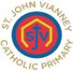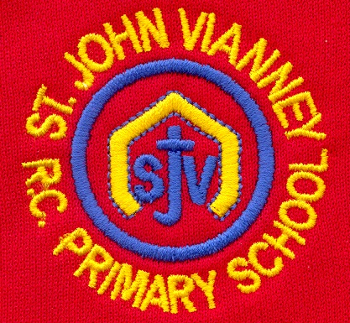

**PSHE**

Health and Wellbeing; Relationships; Living in the Wider World.

**Computing**

***E-Safety:*** examples of technology specific forms of communication; I can explain how someone can get help online; to recognize how online bullying can be different to bullying in person.

**PE**

*Invasion Games*

*Cross Country*

*Dynamic balance to agility*

**French**

Niveau Rouge Module 1: numbers; time; questions; parts of the UK; places in a town; clauses and complex sentences; age; adjectives; bilingual dictionary.

**Science**

***Living Things and their habitats:*** *Children will**d*escribe the differences in the life cycles of a mammal, an amphibian, an insect and a bird; they will be able to describe the life process of reproduction in some plants and animals.

***Properties and changes of materials***

Children will compare and group together everyday materials on the basis of their properties.

They will know that some materials will dissolve in liquid to form a solution and describe how to recover a substance from a solution.

Children will use their knowledge of solids, liquids and gases to decide how mixtures might be separated, including through filtering, sieving and evaporating.

They will demonstrate that dissolving, mixing and changes of state are reversible changes.

Children will be able to explain that some changes result in the formation of new materials, and this kind of change is not usually reversible.

**Year Five – Autumn Term**

**English**

***‘Varjak Paw’ by SF Said***

Narrative; character description; setting description; non-chronological reports

***Non-Chronological Reports***

organisational features; structure

***Poetry: Poems with a structure***

Haiku; limericks

***Myths and Legends***

Settings; typical character roles; plot and storyline; writing their own myth

***Grammar: coordinating and subordinating*** conjunctions; adverbs; speech; synonyms and antonyms; parenthesis; relative clauses; punctuation

**Guided reading –** weekly VIPERS sessions

**Mathematics**

***Place Value:***  reading and writing numbers up to 1,000,000; Comparing numbers to 1,000,000; Rounding numbers up to 100,000

***Addition and Subtraction:*** Adding within 1,000,000; Subtracting within 1,000,000;formal written methods of addition and subtraction

***Multiplication and Division:*** Finding multiplies, factors, common factors; Prime and Composite numbers; Square and Cube numbers; short multiplication; long multiplication; dividing with and without a remainder

***Problem solving:*** Solving multi-stepword problems

***Graphs:*** Reading tables; reading line graphs

**History *Anglo Saxons and Scots***

Children will have an understanding of who the Anglo-Saxons were and why they invaded Britain and settled there. They will understand how Christianity arrived in England and the significance of certain individuals and places of heritage. Children will discover that many changes took place in the North East of England for the Anglo-Saxons during their time.

**Music**

Musical elements. Composing, performing.

Children will learn rhythmic values and sight reading of musical notes.

**Design Technology**

***Food technology:*** Making soup

Researching soups of the world; Evaluating existing soups; Know that climate and conditions affect food production; Design a soup recipe; Understand good hygiene in the kitchen; Make and evaluate soup.

**Art**

Investigating self-portraits by a range of artists, children use photographs of themselves as a starting point for developing their own unique self-portraits in mixed-media.

**Geography *Climate and the World***

Children will gain an understanding of the differences between the weather and the climate. They will use atlases to identify countries and continents with different climate zones. Children will further explore temperate and cold climates.

**Religious Education**

***Ourselves***

Created in the image and likeness of God

***Life Choices***

Marriage, commitment and service

***Hope***

Advent: waiting in the joyful hope for Jesus, the promised one

***Other Faiths:*** **Judaism**

Passover; Seder; Shema Prayer