
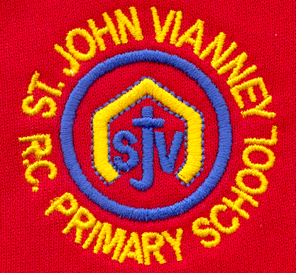

Hillhead Road
West Denton
Newcastle upon Tyne
NE5 1DN
Telephone: 0191 2672233
Fax: 0191 2679538
admin@stjohnvianney.newcastle.sch.uk
www.stjohnvianney.newcastle.sch.uk

Mr A M Duffy
Headteacher
St. John Vianney Catholic Primary School
©

15th April, 2019
Dear Parents and Carers,

Welcome Back!
I would like to welcome you all back to school and hope that you had a wonderful Easter holiday.
As we begin Holy Week, the children will be taking part in child-led Liturgies, Stations of the Cross (led by Year 6) and Mass with Father Martin. This really is a special time to be in school and I know that the children will be as prayerful as always as we journey with them through Holy Week to Easter Sunday.

Easter Egg Raffle
Thank you to everyone who has donated Easter Eggs and bought raffle tickets from our Mini Vinnies. The last day to buy raffle tickets is this Wednesday. The raffle will be drawn on Thursday morning. We are still accepting Easter Egg donations and they are all very much appreciated. Thank you in advance for your support.

National SWAN Day – Friday 26th April
On Friday 26th April, we will once again be supporting SWAN (Syndrome Without A Name) Day in school. Children should come to school in their own clothes and all voluntary donations will go to this charity. More information about the charity can be found on www.geneticalliance.org.uk.

PTFA
Our PTFA are inviting all children to bring in any loose change on Wednesday morning and we aim to fill a large Easter Egg (that Mrs Simonsen has kindly drawn in chalk on the playground) with our loose change. We did something similar during the World Cup and it was very successful. Children should bring any loose change into school on Wednesday morning. Thank you.

Thank you for your continued support of our school.

Yours sincerely,
Mrs C Meldrum









Acting Headteacher

