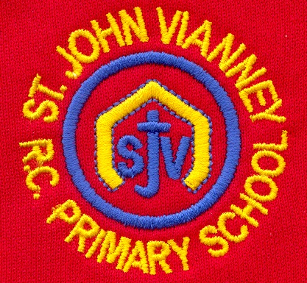

**Religious Education**

**Journeys:**

The children will explore a journey through a year. They will discuss the Christian family’s journey with Jesus through the Church’s year.

**Eucharist:**

The children will study *The Eucharist*. They will explore how we listen to the Word of God and share in Holy Communion and they will explain why Christians want to share the Good News of Jesus.

**Lent/Easter - Giving:**

The children will study Lent. They will learn that Lent is the season when Christians practise both giving and giving-up, to identify with the complete self-offering of Jesus that we remember during Holy Week.

**History**

**Crime & Punishment:**

Children will learn about how our approach to this subject this has evolved from Roman times to the present day.

**Mathematics**

**Place Value-** Round any number to the nearest 10 or 100. Recognise fractions as part of a whole number, shape and as a division of a quantity.

**Calculation-** Solve problems, including missing number problems, and use the inverse operation to check answers.

**Measurement-** Tell and write the time from an analogue clock to the nearest minute. Compare duration of events e.g. the time taken by a particular event or task. Measure the perimeter of simple 2D shapes.

**Geometry-** Identify right angles, recognise two right angles make a half turn, three make a three-quarter turn and four make a complete turn.

**Statistics-** Understand and use Venn and Carroll diagrams to support reasoning for numbers or shapes.

**PSHE**

Health and Wellbeing; Relationships; Living in the Wider World.

**French**

Children will listen to and sequence a story in French (The Hungry Caterpillar). They will learn days of the week, foods, numbers to 10 and they will revise colours in French.

**Music**

Children will begin to learn to play the guitar and keyboard. They will explore notation, basic sight reading of Music and they will be able to play simple chords and melodies.

**P.E.**

Children will take part in Cross Country and Gymnastics activities to build and develop stamina and co-ordination.

**Computing**

**Coding**

In this topic, we will look at Debugging. We will create Art with Code and we will create our own Digital Game.

**Science**

**Plants**

Children will identify and describe the functions of different parts of flowering plants. They will explore and investigate the requirements of plants for life and growth (air, light, water, soil) and they will investigate the way in which water is transported within plants. Pollination and seed dispersal will also be studied.

**Year Three – Spring Term**

**Design Technology**

Children will be learning about structures in our *Banish the Broken Biscuits* investigation. They will explore different packages then design and make their own packaging.

**Art**

Children will explore shape and tone. They will find shapes in everyday objects and draw carefully from observation and practice shading.

**Geography**

**Where we Live:** The children will learn about the different types of settlements and their features.

They will learn to identify these settlements in the United Kingdom.

**English**

**Non-Fiction Text *– The Magic and Mystery of Trees***

Children will write an Explanation Text to explain the life cycle of an Oak Tree.

**Mystery and Adventure Stories**

***The Lion, The Witch and The Wardrobe by C.S Lewis***

Children will read and understand the features of these texts. Children will write a Character Description and a Setting Description, and they will write a persuasive letter in character, based on the story.

**Performance Poetry and Poems with a Structure**

***“The School Teacher’s Rap” by John Foster***

Children will read, write and perform a range of poems. They will explore features such as similes, metaphor, alliteration and rhyme.

**Grammar:** Children will use and understand the correct terminology, e.g. parts of speech, sentence construction and punctuation.

**Handwriting:** Children will continue to use the diagonal and horizontal strokes needed to joinletters.