
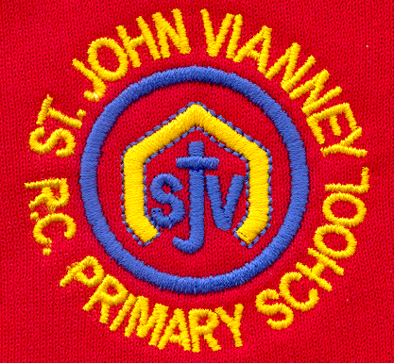

Hillhead Road
West Denton
Newcastle upon Tyne
NE5 1DN
Telephone: 0191 2672233
Fax: 0191 2679538
admin@stjohnvianney.newcastle.sch.uk
www.stjohnvianney.newcastle.sch.uk

Mr A M Duffy
Headteacher
St. John Vianney Catholic Primary School
©

4th October, 2019
Dear Parents and Carers,

Curriculum Evenings
Thank you to everyone who attended our Curriculum Evening on Tuesday night. We have received wonderful feedback about the workshops that we delivered, including the E-Safety and Cyber Bullying workshop. If you were unable to attend, the Powerpoints that the teachers showed are now displayed on our school website. Please take time to have a look at the curriculum we are offering our children in school this year.

PTFA Raffle
Our Year 6 children drew the PTFA Raffle on Tuesday afternoon. A list of prize winners is displayed on the front door of school. Please check the list incase you have won a prize!

PTFA Fashion Show
Our PTFA are hosting a Fashion Show on Saturday 2nd November at West Denton Community Centre, Hillhead Road. This is a chance for you to shop your favourite high street brands at 50% off or more! Tickets cost £6.00 each and they are available from Mrs Marsh, who is vice-chair of the PTFA. Please see the poster overleaf for more information.

Reading Books
Can I please ask that you make sure to sign your child’s Reading Record book to enable us to monitor the books that your child is Reading as part of their home-school Reading. If Reading Record books are not signed, then it would indicate that your child has not read their book and their book will therefore not be changed in school. We are continually monitoring the texts that our pupils are reading both inside and outside of school so your support in this is much appreciated.

We have had a super start to this academic year and we look forward to working with you all over the forthcoming months because, working together, we really can achieve the very best for the children of St. John Vianney Catholic Primary school.

Yours sincerely,

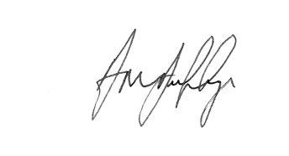
Mr A M Duffy





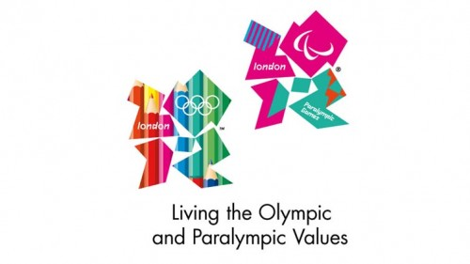



Headteacher

