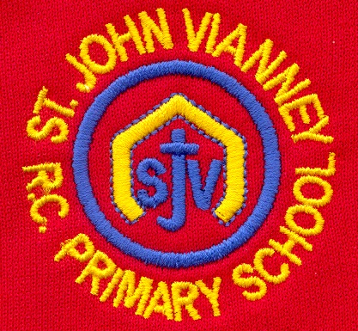

**French**

Children will learn countries and capital cities of the UK and use the conjunction 'ou'. They will identify Paris landmarks, ask and answer questions and learn numbers 7-10.

**Music** Children will sing in a three-part round. They will learn new songs that increase fluidity in their voices and help to separate vocal parts. Children will critically analyse live and recorded music using increasingly complex musical language. Children will continue to develop their music reading skills and begin to transcribe rhythms clapped to them.

**P.E.**

Children will take part in Athletics, Team Games & Gymnastics – linking combinations and using a range of jumps and balances.

**Design Technology**

Lesson in a box in association with NISSAN. This is an 8 week project led by the Nissan Skills Foundation.

**PSHE**

Health and Wellbeing; Relationships; Living in the Wider World.

**Religious Education**

**Journeys:**

The children will explore a journey through a year. They will discuss the Christian family’s journey with Jesus through the Church’s year.

**Eucharist:**

The children will study *The Eucharist*. They will explore how we listen to the Word of God and share in Holy Communion and they will explain why Christians want to share the Good News of Jesus.

**Lent/Easter - Giving:**

The children will study Lent. They will learn that Lent is the season when Christians practise both giving and giving-up, to identify with the complete self-offering of Jesus that we remember during Holy Week.

**Mathematics**

**Multiplying and Dividing-** Multiplying and dividing by 3, 4, 8. Multiplying and dividing two digit numbers. Multiplying with renaming and solving multiplication and division word problems.

**Length-** Writing lengths in metres, centimetres and millimetres; comparing lengths; solving word problems.

**History**

**Bronze Age to Iron Age:** Prehistory – what does this mean? Survival in the Stone Age – dwellings; hunter gathers; beliefs. Farming in the Stone Age. Case study – Skara Brae

**Science**

**Plants**

Children will identify and describe the functions of different parts of flowering plants. They will explore and investigate the requirements of plants for life and growth (air, light, water, soil) and they will investigate the way in which water is transported within plants. Pollination and seed dispersal will also be studied.

**Year Three – Spring Term**

**English**

**Guided reading:**

David Attenborough, Disney lyrics and Jim and the Beanstalk.

**Handwriting:**

Cursive letter formation, letter joins, letter joins mastery, ascenders and descenders mastery, uppercase letters and numbers correctly sized, spacing within and between words

**Grammar:** Subject/verb focus: what is a subject? Building single-clause sentences, including pronouns, co-ordinating conjunctions to join clauses and compound subjects.

**Spelling:** one spelling lesson per week, which focuses on the current week’s spellings. Including word etymology, syllable maps, phoneme maps and word definitions.

**Computing**

**Coding**

In this topic, we will look at Debugging. We will create Art with Code and we will create our own Digital Game.

**Geography**

**Water and the Water Cycle:** The children will learn about the water cycle, who uses water and how we can save water. They will also learn about problems with water in the world.