
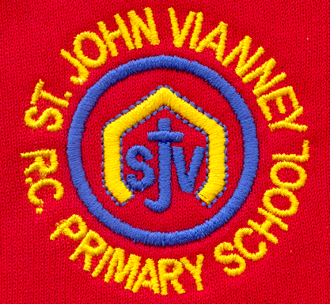

Hillhead Road
West Denton
Newcastle upon Tyne
NE5 1DN
Telephone: 0191 2672233
Fax: 0191 2679538
admin@stjohnvianney.newcastle.sch.uk
www.stjohnvianney.newcastle.sch.uk

Mr A M Duffy
Headteacher
St. John Vianney Catholic Primary School
©

11th October, 2019

Dear Parents and Carers,

Harvest Mass
We are collecting contributions of tins and packets of food for our Harvest Mass, which will take place next Friday in church. Unfortunately, due to number restrictions in church, we are unable to extend the invite to parents and carers since the church can accommodate 350 pupils and our school population is over 400 pupils. All donations should be brought into school next week and these will be blessed by Father Martin at Mass on Friday. Thank you in advance for your generosity.

Congratulations Mrs Watanabe!
I’m sure you will join me in congratulating Mrs Watanabe on the birth of her new baby son, Akira. Both Mrs Watanabe and Akira are doing very well and we wish Mr and Mrs Watanabe every happiness with their new arrival.

Christmas Cards
Every child at school has produced their own Christmas card and these will be printed by a professional company. You should receive your child’s Christmas card next week. We require all cards to be returned to school by MONDAY 4th NOVEMBER. All payment must be made online through the Cauliflower Cards website. Instructions are detailed on the order form that your child will bring home. School will not be handling any monies or payment this time. We have been assured that the printed cards will be sent to school by the beginning of December at the latest. The cards are being collected for printing after school on Monday 4th November so any cards not returned to school by Monday 4th November must be posted directly to the company by individual parents and carers.

Parents Evening
By now, you will have received a letter about Parents Evening on Monday 21st, Tuesday 22nd and Wednesday 23rd October. Please return your reply slip to school by MONDAY so that class teachers can allocate times for meetings. Many thanks.

Earrings in school
Can I please remind you once again that earrings are not allowed in school for health and safety reasons. This includes the transparent retainer earrings that a number of children are wearing in school. The retainer earrings can also cause injury, which is why we ask you to support us in our school uniform policy. Any child who has just had their ears pierced must have the earrings covered with tape before coming into school. Can I thank the vast majority of parents and carers who do support us when politely requested to do so.

PTFA Fashion Show
This is just a reminder that our PTFA are hosting a Fashion Show on Saturday 2nd November at West Denton Community Centre, Hillhead Road. This is a chance for you to shop your favourite high street brands at 50% off or more! Tickets cost £6.00 each and they are available from Mrs Marsh, who is vice-chair of our PTFA. Please see the poster at the entrance to school for more information.

Year 6 Class Liturgy
Year 6 would like to invite their parents, carers and friends to their Class Liturgy on Wednesday 16th October at 9.15am in the school hall. We look forward to seeing you there.

Thank you for your continued support of our school.

Yours sincerely,

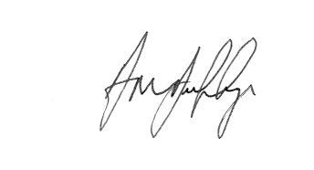
Mr A M Duffy
Headteacher











