
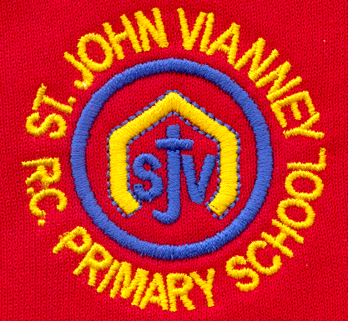

Hillhead Road
West Denton
Newcastle upon Tyne
NE5 1DN
Telephone: 0191 2672233
Fax: 0191 2679538
admin@stjohnvianney.newcastle.sch.uk
www.stjohnvianney.newcastle.sch.uk

Mr A M Duffy
Headteacher
St. John Vianney Catholic Primary School
©

4th July, 2019
Dear Parents and Carers,
Mrs Duffy’s Reception Class Liturgy
On Wednesday morning, Mrs Duffy’s Reception class led their family, friends and members of the parish community in a wonderful Liturgy about God’s Wonderful World. The children sang their hearts out and they narrated and acted out the story of Noah’s Ark brilliantly. Well done Reception!

Well done Key Stage 1!
On Wednesday and Thursday afternoon, Year 1 and Year 2 performed Aesop’s Fables to a packed school hall. The children were absolutely fabulous and their singing nearly lifted off the roof of the hall! It was also lovely that, as well as many parents / carers and friends of the school, our governors also came to support our children. All of the staff were extremely proud of all of our children. Well done Key Stage 1!

Year 6 Leaver’s Mass
On Thursday afternoon, Year 6 took part in the Newcastle Catholic School’s Leaver’s Mass, which was conducted by our new Bishop, Bishop Robert. The behaviour and reverence of all our children was outstanding and it really was a lovely celebration for the Year 6 children leaving our school in July.

Sports Day
This is just a reminder that Key Stage 2 Sports Day will take place on Monday afternoon and Key Stage 1 Sports Day will take place on Tuesday afternoon. Gates will open at 1.45pm ready for a 2pm start. Our PTFA will be providing every child in school with an ice pop and they will also be selling refreshments at the KS1 and KS2 Sports Days. Thank you in advance for your support.

Year 5 Residential Visit to Kingswood
Our Year 5 children are currently staying at Kingswood Activity Centre in Hexham. Everyone is having a wonderful time and we look forward to hearing all about it when they return on Friday.
Thank you for your continued support of our school.

Yours sincerely,
Mr A M Duffy





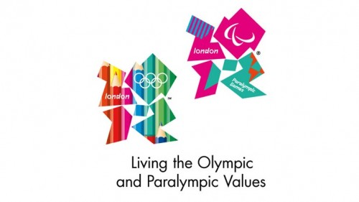



Headteacher

