
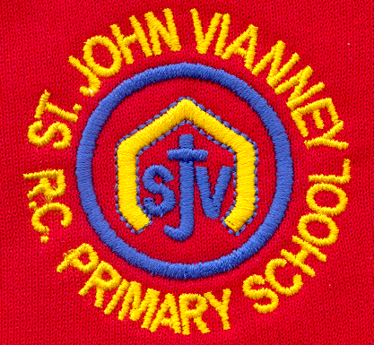

Hillhead Road
West Denton
Newcastle upon Tyne
NE5 1DN
Telephone: 0191 2672233
Fax: 0191 2679538
admin@stjohnvianney.newcastle.sch.uk
www.stjohnvianney.newcastle.sch.uk

Mr A M Duffy
Headteacher
St. John Vianney Catholic Primary School

15th July, 2020

Dear Parents and Carers,

Reopening of School for All Children in September

Following DFE and Government guidance released on Thursday 2nd July, I am writing to inform you that school will be open from Tuesday 8th September, 2020 to all pupils in school. School will be open full time from Monday – Friday.
In line with Government guidance, children will be organised into year group bubbles so that we can try to manage social distancing as effectively as possible. To try and control any risk, children will have to sit at a desk facing the front of the class and any movement will have to be limited in order to prevent children coming into close contact with each other. Each group will be taught by their class teacher which will create a self-contained ‘bubble’.
Government guidance states that children will not be able to mix with other ‘bubbles’ and this has many implications:
- We are going to stagger lunchtimes and break times which will need to be managed very carefully so that year group bubbles do not mix.
- The start and the end of the school day will be ‘staggered’ in order to ensure social distancing. It is vital that we follow these measures to keep the number of transmissions as low as possible.
Risk Assessment
Our Risk Assessment is available online for your information. If you have any questions or queries, please do not hesitate to contact the school.

The Proposed Plan for September
Each year group bubble will be brought into school at ten minute intervals to enable social distancing to take place. You will be sent a timetable during the Summer holidays outlining the start and finish times for your child. Parents/carers with more than one child in school will be able to drop off and collect all children at the same time and we will write to you individually outlining this procedure and these start and finish times.
It is important to note that all of these arrangements are subject to change in light of the continual publication of new Government guidance but, at the present time, this is the proposed plan for September.

Important Information
Arrival / Collection Arrangements
The start and finish times for your child will be posted out to you during the holidays. However, the proposed plan currently is as follows:
Year Group Bubble | Start Time | Dismissal Time
Year 6 | 8.30am | 3.30pm
Year 5 | 8.40am | 3.20pm
Year 4 | 8.50am | 3.10pm
Year 3 | 9.00am | 3.00pm
Year 2 | 9.10am | 2.50pm
Year 1 | 9.20am | 2.40pm
Reception  AFTER INDUCTION PERIOD | 9.30am | 2.30pm
Nursery  AFTER INDUCTION PERIOD | 9.40am | 2.20pm

We will review these start and finish times weekly. If we feel it is safe and manageable to shorten these times to 5 minute intervals once children and parents/carers become more familiar with the routines in operation, then we will do so only if it considered safe to do so.
- We ask that only 1 parent/carer brings and drops off their child and we require all parents/carers to adhere to social distancing guidelines. We ask that you turn up to collect your child at the time indicated on the letter that we will send out to you and not before to avoid parents/carers congregating on Hillhead Road. Mrs Meldrum and Mrs McDine will wait at the school gate and will only allow parents/carers of the correct year group bubbles access to the school grounds at their allocated times. Signs will be in operation to inform you which bubble should line up/ which bubble is being dismissed at any given time. Parents/carers of children in Year 1 – 6 should collect their child from the Marked Bays in school as normal. Any other children and parents/carers who arrive are to wait until their allocated slot. Parents/carers of children in Nursery and Reception should make their way to the Early Years yard at their allocated time.
Collection Arrangements
- Children should be collected at their allocated times by one adult. Parents/carers are requested to be punctual at drop off and collection times.
School Uniform
- Children are required to wear full school uniform as per the school’s Uniform Policy. To minimise any potential infection risk, we ask that children wash their hands on arrival and departure in classrooms.
- Any child who is unable to tie their shoe laces independently should also wear Velcro footwear in order to minimise the infection risk between pupil-adult.
Siblings
- Children with siblings can travel into school together and they will be directed to their allocated bubbles by a member of the school’s Management team, who will be standing at the school gate.
- Children with siblings can be collected together. This will be managed by the Management team so please wait beside the Marked Bays as normal to collect your child and we will ensure the safe handover of siblings to you. Parents/carers with siblings will be informed of drop off and collection times and these will be posted out once finalised.

Distressed Child Entering School
• In the event that your child is extremely distressed and finding it difficult to enter school, we may not be able in the first instance to accommodate your child because of our aim to try and maintain a teacher and child designated bubble, e.g. other staff are unable to come in and help as they will be entering that bubble. We will work closely with you to establish how we might best integrate your child back into school should this continue to be a problem.

Lunch times
- To avoid the mixing of bubbles in the school Hall, children will need to bring with them a packed lunch and these should be brought into school in a disposable carrier bag. Children will eat packed lunches in their classroom within their bubble. Carrier bags will be disposed of after lunch in order to minimise the possible spread of infection between school and home. Children receiving Free School Meals and all children in Reception, Year 1 and Year 2 will be provided with a free, universal packed lunch under the current Government scheme.
- Children are allowed to bring with them a water bottle into school but this must be clearly labelled with your child’s name. No items, other than a water bottle and a packed lunch in a disposable carrier bag, should be brought into school from home.
- PE kits and Reading Folders should be brought into school on Monday 14th September. P.E kits from this academic year will be sent home on Tuesday 8th September.
- In our attempts to minimise infection risk and spread, no school bags are to be brought into school. Homework will comprise online learning, and spellings for every half term will be displayed on the school website in the Home Learning section. Letters will also be posted on our website and Mrs McDine will text you as normal in order to draw your attention to newly posted letters.

Contacting the School Office
We ask that parents and carers do not come into the school building but contact the school office by email or telephone. If the query cannot be dealt with using email/telephone then an appointment will be made.
We will update you again during the Summer holidays of any additional information or change to these proposed arrangements prior to the 8th September to give you all as much notice as possible.

Thank you again for your patience, understanding and co-operation in these challenging times.
Yours sincerely,

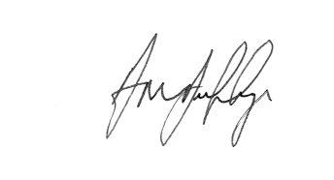
Mr A M Duffy
Headteacher




