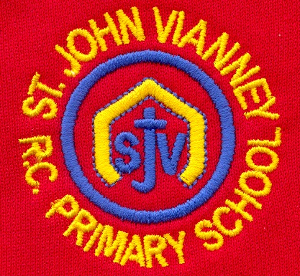

**PSHE**

Health and Wellbeing; Relationships; Living in the Wider World.

**P.E.**

***Multi Skills:*** rolling, throwing, catching, jumping. Use a combination of movement skills through different games and sports.

**Music**

***Singing:*** Posture, Chants, Pitch, Pentatonic Songs, Dynamics, Tempo, Call and response.

Basic Rhythms, singing loud and quiet, actions

**History**

***The Gunpowder Plot:*** understanding events, describing Guy Fawkes. Using different sources to find out about the past. Order events on a timeline.

**Art**

**Drawing**

Exploring mark making and line; working and experimenting with different materials through observational and collaborative pieces.

**Geography**

**Climates around the World**

Atlas work; Northern and Soutern Hemispheres; Understanding the Equator; Study of 2 contrasting locations (Alaska and Sahara)

**Mathematics**

***Place value:*** read and write numbers to 100 (numerals and words) recognise the value of each digit in a 2 digit number.

***Properties of number and number sequences:*** counting in steps of 2, 3, 5 and 10

***Fractions:*** recognise ½ 1/3 ¼ and 3/4, write simple fractions of amounts and shapes.

***Developing and Applying calculation:*** Recall addition and subtraction facts to 20 fluently. Add and subtract numbers.

**Multiplication and Division:** Recall and use multiplication and division facts for 2, 3 5, and 10 times tables.

**Design Technology**

***Puppets:*** design a product for a purpose. Use running stitch to join fabrics. Colour and decorate textiles. Evaluate ideas and product against criteria.

**Year Two – Autumn Term**

**Computing**

***E_Safety:*** Creating Media – Capture, edit and improve images through digital photography.

**Science**

***Living Things and Habitats:*** Explore and compare differences of objects / items living, dead & never been alive. Life processes MRS GREN movement, respiration, sensitivity, growth, reproduction, excretion & nutrition.

Habitat suitability, naming plants and animals including mini beasts. Understanding food chains.

**English**

**‘The Deep Dark Wood’** by Algy Craig Hall and Ali Pye

Setting; characters; discussion & comprehension. Stories with familiar settings.

**‘The Dark’** by Lemony Snicket

Writing Instructions**;** Plan and write short story; non-chronological report

**A Walk in the Woods (Poetry)** by Dennis Lee

Performance Poetry; character analysis; poem structure

**Coming Home to England** by Floella Benjamin

Black History Month; Author Fact File; non-chronological report

**Greta and the Giants** by Zoe Tucker

Persuasive poster; biography

**Christmas Poetry**

Acrostic Poem

**SPAG (Spelling Punctuation & Grammar):** Capital letters and full stops, question marks, exclamation marks bullet points, commas in a list, adjectives to describe nouns, commas in a sentence, conjunctions & past and present tense. Phase 5 phonics Letters & Sounds.

**Religious Education**

***Beginnings***

God is present in every beginning

***Signs and Symbols***

Signs and Symbols used in Baptism

***Preparations***

Four weeks of preparation for the celebration of Jesus at Christmas

***Other Faiths: Judaism***

Signs and symbols of the Jewish festival of Shabbat