
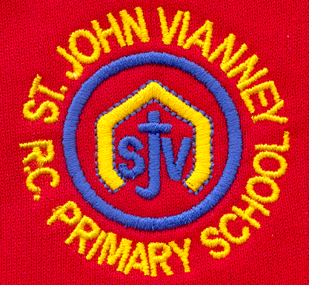

Hillhead Road
West Denton
Newcastle upon Tyne
NE5 1DN
Telephone: 0191 2672233
Fax: 0191 2679538
admin@stjohnvianney.newcastle.sch.uk
www.stjohnvianney.newcastle.sch.uk

Mr A M Duffy
Headteacher
St. John Vianney Catholic Primary School
©

5th April, 2019
Dear Parents and Carers,

Newcastle Dance Festival
On Wednesday, our Year 5 children took part in the Newcastle Schools Dance Festival. They performed to ‘Ways to Be Wicked’ from the Disney Action film, Descendants 2. The children were all absolutely amazing and they did St. John Vianney school proud. Well done Year 5, you were simply brilliant!

Science Week
What a fabulous Science week we have had in school! The children have all thoroughly enjoyed their journey into Science this week through the variety of workshops, activities, projects and investigations in which they have taken part, and hopefully we have inspired a new generation of Scientists! Thank you to Mr Bonnar and Mr Peacock, our Science Co-ordinators, and to all of the Scientists and High School colleagues who have been involved in our Science Week. We have had a very exciting end to our school term.

Well done to our Cross Country Winners!
On Tuesday, our school took part in the Newcastle City Schools Cross Country Championships. All of our runners were absolutely fantastic and Miss Cherry, our PE Co-ordinator, was extremely proud of everyone involved. We were all especially delighted when Charlie, a pupil in Year 4, won the Under 9 boy’s race! What an outstanding achievement for our school. Unfortunately, the Catholic Schools Cross Country competition was cancelled this week due to adverse weather conditions. We look forward to the rescheduled race on Wednesday 22nd May. Good luck everyone!

Year 1 Visitor
On Tuesday afternoon, Year 1 welcomed a Rail enthusiast and Engineer, Ian, who came into school to talk to the children about George Stephenson and the railways. The children found out lots of important information to support the work they are doing in school. A great afternoon was had by all!

PTFA
We are currently looking for new recruits to come and join our PTFA. All are welcome! If you are interested in coming to our half-termly meetings or simply helping out at events, then please call at the school office. Thank you.

Easter Holidays
I hope you all have a wonderful Easter holiday and I look forward to welcoming you back to school on Monday 15th April.

Thank you for your continued support of our school.

Yours sincerely,
Mrs C Meldrum
Acting Headteacher











