
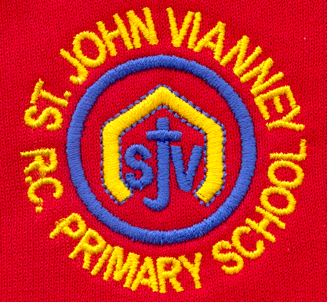

Hillhead Road
West Denton
Newcastle upon Tyne
NE5 1DN
Telephone: 0191 2672233
Fax: 0191 2679538
admin@stjohnvianney.newcastle.sch.uk
www.stjohnvianney.newcastle.sch.uk

Mr A M Duffy
Headteacher
St. John Vianney Catholic Primary School

19th May 2020

Dear Parents and Carers,

Possible Safe Phased ‘Reopening’
I am writing to update you about the possible phased ‘re-opening’ of St John Vianney following the announcement made by the Prime Minister on the 10th May. Since then, we have received substantial guidance from the government which is constantly being updated. You can find some of that information below:
Guidance for Schools Actions for Schools Guidance for Parents

As you know, school is currently open for vulnerable children and the children of key workers and this will continue to be the case until the end of the summer term. As we make preparations for a wider opening, we need to find out how many children from this priority group will be requiring a place from the 1st June so that we can plan for any additional children to return safely. Presently, we don’t know the exact size of this group as some families have been following previous government guidance and keeping their children at home when they have been able to safely do so.
The government has also announced that from Monday 1st June, schools may start to reopen for Nursery, Reception, Year 1 and Year 6 children. The government has explained that this is to prioritise early learning and to help transition. Again, in order to be able to determine how this can be done safely, we would like to seek an indication of how many families from these classes plan to send their children to school when an increased number of children can do so.
As has been stated many times throughout all correspondence, the absolute priority when deciding to open the school to greater numbers must always be the safety of children, staff and the families of children and staff.
The government has provided a lot of detail about how we can do this as safely as possible, which will mean that the school the children return to, will be substantially different to the one that closed on Friday 20th March.
Guidance states that children will need to be organised into groups of no more than 15 so that we can try to manage social distancing as effectively as possible. Due to the size of the classrooms at St John Vianney, this number is likely to be even lower. To try and control any risk, children will have to sit at a desk by themselves and any movement will have to be limited in order to prevent children coming into close contact with each other. Each group will have to be taught by the same teacher which will create a self-contained ‘bubble’. Unfortunately, this means that your child may not be taught by their current class teacher and may not be sat at a desk in their current classroom. This will remain the case until the end of the summer term unless the government changes its guidance.
Government guidance states that children will not be able to mix with other ‘bubbles’ and this has many implications:
- We will need to stagger lunchtimes and break times which will need to be managed very carefully so that children stay 2 metres apart.
- Children in one ‘bubble’ will not be able to mix with children from another ‘bubble’ at any point during the school day, even if they are in the same year group.
- The start and the end of the school day will be ‘staggered’ in order to ensure social distancing.

It is vital that we follow these measures to keep the number of transmissions as low as possible.

In order for us to plan to open on a wider basis, it is vital that we know which children parents intend to send into school, so your help with this is crucial. Although the government have asked to encourage you to send your child to school, they have also confirmed that parents will not be fined or penalised for choosing to keep their children at home.

What Should I Do Now?
We would like the parents of children in Nursery, Reception, Year 1 and Year 6 as well as Key Workers and Parents of Vulnerable Children to complete the survey on our school website under the heading ‘Potential School Re-opening Survey’ by 4pm on Wednesday 20th May. Please complete a separate survey for each child you have in school. You can email your response to us if you’d prefer. If you have any problems completing the survey, please contact the school.
Thank you again for your patience, understanding and co-operation in these challenging times.

Yours sincerely,

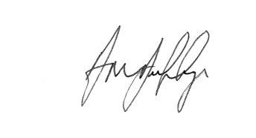
Mr A M Duffy
Headteacher





