
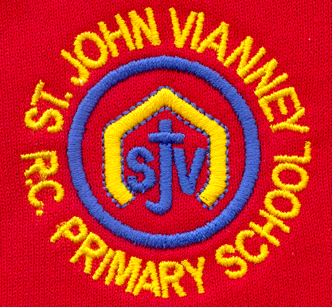

Hillhead Road
West Denton
Newcastle upon Tyne
NE5 1DN
Telephone: 0191 2672233
Fax: 0191 2679538
admin@stjohnvianney.newcastle.sch.uk
www.stjohnvianney.newcastle.sch.uk

Mr A M Duffy
Headteacher
St. John Vianney Catholic Primary School
©

11th September, 2020

Dear Families,

Welcome Back
On behalf of all the Governors and Staff at St. John Vianney Primary school, I extend a warm welcome back to you all. The children have all settled in really well to school and we are delighted with the way they have coped with all the new systems that are in place. I would like to thank you all for your patience and co-operation with the new drop off and pick up procedures. Can I also thank the vast majority of parents/carers who drop off their child and then leave the school gate immediately to prevent a bottle neck situation on Hillhead Road. Your help in this is greatly appreciated.

Changes to Drop-off Times – Starting MONDAY 14th SEPTEMBER
Due to the way the children have adapted quickly to the new system, we are changing the drop off and pick up times to five minute intervals between classes from MONDAY 14th SEPTEMBER.
The new times are shown on the table below.

Please note that the same system for siblings is in operation. Children should come into school with the oldest sibling and then leave with the youngest sibling.

Year Group Bubble | Old Drop-off  Time | New Drop-off  Time | Old Pick-up  Time | New Pick-up  Time
Year 6 | 8.30am | 8.30am | 3.30pm | 3.30pm
Year 5 | 8.40am | 8.35am | 3.20pm | 3.25pm
Year 4 | 8.50am | 8.40am | 3.10pm | 3.20pm
Year 3 | 9.00am | 8.45am | 3.00pm | 3.15pm
Year 2 | 9.10am | 8.50am | 2.50pm | 3.10pm
Year 1 | 9.20am | 8.55am | 2.40pm | 3.00pm
Reception  DURING INDUCTION | 9.30am  No change | 9.30am  No change |  | See Induction  Timetable
Nursery  DURING INDUCTION | 9.40am  No change | 9.40am  No change |  | See Induction  Timetable
Social Distancing
Can we please politely remind adults waiting to drop off and pick up their children on Hillhead Road to adhere to social distancing guidelines in light of current Government advice. Can we also politely remind you that only that only one parent/carer should drop off and collect your child at the end of the day and that all water bottles and packed lunches MUST be clearly labelled with your child’s name to keep us COVID safe. Thank you for your co-operation.

Music Tuition for Year 5 and Year 6 pupils
If you have a child in Year 5 or Year 6 who is interested in continuing or starting instrumental lessons, please read Miss West’s letter under the News section of our website and send your reply to admin@stjohnvianney.newcastle.sch.uk as soon as possible.

Reading Books and P.E. Kits
Please send Reading Folders and P.E. Kits into school on Monday 14th September. P.E. kits will remain in school and books in Reading Folders will all be quarantined in line with Government guidance. We are currently investigating an online Reading scheme so that children’s home-school Reading books will be accessed online and we will keep you updated about this over the next few weeks.
This term, all letters will continue to be posted online and Mrs McDine will inform you of any letters posted via text message in the normal way.

Earrings in School
A number of children arrived in school on Tuesday wearing earrings. Can I please remind you that NO jewellery other than a watch is allowed in school. For health and safety reasons, it is important that NO earrings including see-through studs are worn in school. Parental support in this matter is essential.
If children have newly pierced ears, the ear lobe may be taped temporarily (4 to 6 weeks) with non-allergic (hypo allergenic) micro porous tape if it is necessary to retain the stud in place for medical reasons but children are not allowed to take part in any PE whilst earrings are temporarily covered with tape. Can I also remind you that dogs are not allowed on the school premises for health and safety reasons. Thank you for your co-operation in this matter.

Welcome Back Miss Elliott!
I am delighted to welcome back Miss Elliott to St. John Vianney school. Miss Elliott will be working alongside phase leaders delivering Liturgies and Collective Worship to children in their year group bubbles. This is a key part of our Spiritual and RE curriculum and we look forward to resuming year group Liturgies next week.

Fruit for Key Stage 2 pupils
Children in Nursery, Reception, Year 1 and Year 2 are offered a piece of fruit daily as part of the universal offer from the Government. Children in Years 3, 4, 5 and 6 are invited to bring into school a piece of fruit from home as their morning snack if they wish to do so. They will eat this at playtime as normal.
Can I personally thank you for your patience, understanding and co-operation in these challenging times.
With my very best wishes,
C.Meldrum
Acting Headteacher

