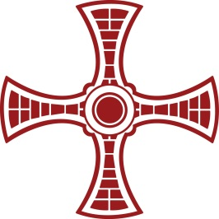

Diocese of Hexham and Newcastle

Newcastle City Council

Instrument of Government

St John Vianney RC Primary School

LA No: 391
School No: 3477

DIOCESE OF HEXHAM AND NEWCASTLE

St John Vianney RC Primary School

Instrument of Government
1. The name of the school is St John Vianney RC Primary School.
2. The School was founded by and is part of the Catholic Church. The school is to be conducted as a Catholic School in accordance with Canon Law and the teachings of the Catholic Church, and in accordance with the Trust Deed of the Diocese of Hexham and Newcastle and in particular:
(a) religious education is to be in accordance with the teachings, doctrines, discipline and general and particular norms of the Catholic Church;
(b) religious worship is to be in accordance with the rites, practices, discipline and liturgical norms of the Catholic Church;
and at all times the school is to serve as a witness to the Catholic faith in Our Lord Jesus Christ.
3. The School is a voluntary aided school in the trusteeship of the Diocese of Hexham and Newcastle and is an exempt charity for advancing the Catholic religion in the Diocese by such means as the Bishop thinks fit and proper.
4. The name of the governing body is: The Governing Body of St John Vianney RC Primary School.
5. The governing body shall consist of:
(a) 7 foundation governors;
(b) 2 parent governors;
(c) 1 head teacher;
(d) 1 staff governor;
(e) 1 local authority governor;
(f) 0 co-opted governors.
6. Total number of governors: 12
7. Foundation governors shall be appointed and may be removed by the Bishop of the Diocese of Hexham and Newcastle (or any other person exercising Ordinary jurisdiction in his name including, where the See is vacant or impeded, the person or persons on whom the governance of the See has devolved).
8. The term of office for every foundation governor shall terminate four years from the date of appointment.
9. This Instrument of Government comes into effect on 2 April 2015.
10. This Instrument of Government was approved by the Diocese of Hexham and Newcastle on 31 March 2015 and made by order of Newcastle Local Authority on [date of making].
11. A copy of this Instrument of Government must be supplied to every member of the governing body (and any headteacher if not a governor), and the Diocese of Hexham and Newcastle.

