
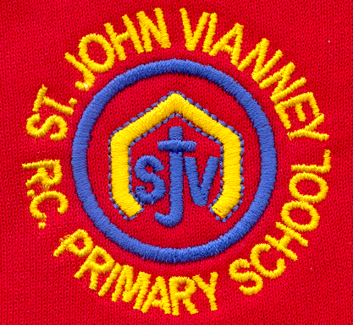

Hillhead Road
West Denton
Newcastle upon Tyne
NE5 1DN
Telephone: 0191 2672233
Fax: 0191 2679538
admin@stjohnvianney.newcastle.sch.uk
www.stjohnvianney.newcastle.sch.uk

Mr A M Duffy
Headteacher
St. John Vianney Catholic Primary School
©

1st February, 2019
Dear Parents and Carers,
Parents Consultation Evening
We would like to invite all of our parents and carers into school for our mid-year Parents Consultation Evening after the half-term holidays. Appointments will be available during week beginning Monday 18th March. We will send out an appointment letter nearer the time for you to complete but I wanted to give you all as much notice as possible.

Year 4 Class Liturgy
Thank you to Mr Peacock’s Year 4 class, who led their parents, carers and friends in a wonderful Liturgy about Building Bridges on Wednesday morning.
Our next Liturgy will take place on Wednesday 13th February, where Miss McMaster’s class will lead their parents, carers and friends in a special Liturgy about Friendship.

Durham Vocal Festival
Our School Choir has been nominated to represent our region in this year’s North East KS2 Choir of the Year. On Wednesday, Mr Duffy, Miss West and our school choir will travel to Durham Cathedral to take part in this prestigious event. Our school choir have worked extremely hard in preparation for this event and we are very proud of their achievements in getting this far in the competition.

Thank You!
I would like to say a big thank you to everyone who has donated books and board games to school. As a school, we are looking at Writing across the school this year and we know the impact that reading high quality texts can have on children’s writing. We have recently spent a considerable amount of money to improve the range and quality of reading material that our children use in school and your book donations are helping to increase the variety of books that we offer in our class libraries. Our PTFA have been a wonderful support in helping us buy new books in school so thank you to everyone who has supported our PTFA. As a school, we are also looking at the wider curriculum in school and we will be looking to buy new resources to strengthen even further our Foundation Subjects, for example Art, Design Technology, History, Geography etc. but we will keep you updated throughout the term.

Balance Bikes
Our Reception children are taking part in a project that is run and managed by The British Cycling organisation and funded by Sport England. Every week, children in Reception are taking part in a group session to develop their sense of balance and pre-riding skills using balance bikes. The aim is get more young children active and confident riding bikes. This is another wonderful example of how we are promoting and supporting the wider curriculum within our school.

School Uniform
Can I please remind you all that, when the weather is inclement, children are allowed to come into school wearing wellies or boots but these must be changed once the children come into school into black school shoes, which is our uniform policy. Thank you in advance for your support and co-operation.

Well Done!
Well done to our Football team, who beat Royal Grammar School 4-2 in the Bob Maddison Knockout Cup last Friday evening. Our next match is against St. Bede’s in the Catholic Schools cup. Well done to Mr Cowen, Mr Bonnar and all of the team – this is an excellent achievement against a very strong and in-form football team.

Questionnaire
This week, your child will have brought home a letter about an online questionnaire for you to complete about our school.
In order to continue to develop our school in a positive and effective way, we would like to ask for your help in finding out what you think would make St. John Vianney Catholic Primary School a better place for your children. We have designed a questionnaire to record your feedback and your child will have brought home a letter detailing instructions about how to complete the questionnaire online.
It is important to emphasise that a nil response will be taken as confirmation that you are happy with everything we presently do at St. John Vianney School.

Thank you for your continued support of our school.
Yours sincerely,
Mr A M Duffy
Headteacher




