
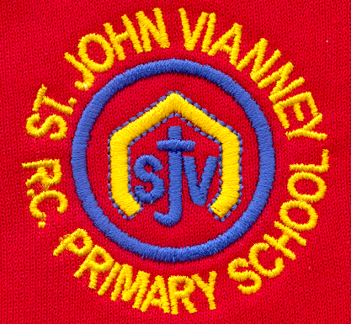

Hillhead Road
West Denton
Newcastle upon Tyne
NE5 1DN
Telephone: 0191 2672233
Fax: 0191 2679538
admin@stjohnvianney.newcastle.sch.uk
www.stjohnvianney.newcastle.sch.uk

Mr A M Duffy
Headteacher
St. John Vianney Catholic Primary School
©

13th May, 2019
Dear Parents and Carers,

First Holy Communion
On Saturday 4th May and Saturday 11th May, our Year 4 children made their First Holy Communion in St. John Vianney church. Our children have worked very hard all year through their Sacramental Preparation and their First Holy Communion Mass was a wonderful celebration of this. The behaviour, reverence and attitude displayed by all of our children was truly outstanding and I have received some wonderful feedback from parents and relatives/friends who attended our First Holy Communions this year. I must say a huge thank you to Miss Elliott, our retired School Chaplain, Father Martin, Mr Bonnar, Mr Peacock and all of our catechists, who have led our children through their Sacramental Preparation this year. Their hard work has been very much appreciated. I must also thank our staff, PTFA and parishoners, who have helped to organise the First Holy Communion breakfast and refreshments afterwards. A big thank you to you all.

Year 6 SATs Week
This week, our Year 6 children will sit their National SATs tests. These are compulsory tests that all Year 6 pupils must sit this week across the country. Our children have been working very hard all year for these and we are very proud of the hard work and dedication shown by each one of them. Good luck Year 6 – we know you will be brilliant!

Dates for Diary
Can I please remind you that our School Photographer will be coming into school on Wednesday 22nd May.
We are also having two training days this term. As we have already informed you, these are:

Friday 21st June: Staff Training Day - School closed to pupils
Friday 19th July: Staff Training Day – School closed to pupils

Thank you for your continued support of our school.

Yours sincerely,
Mr A Duffy

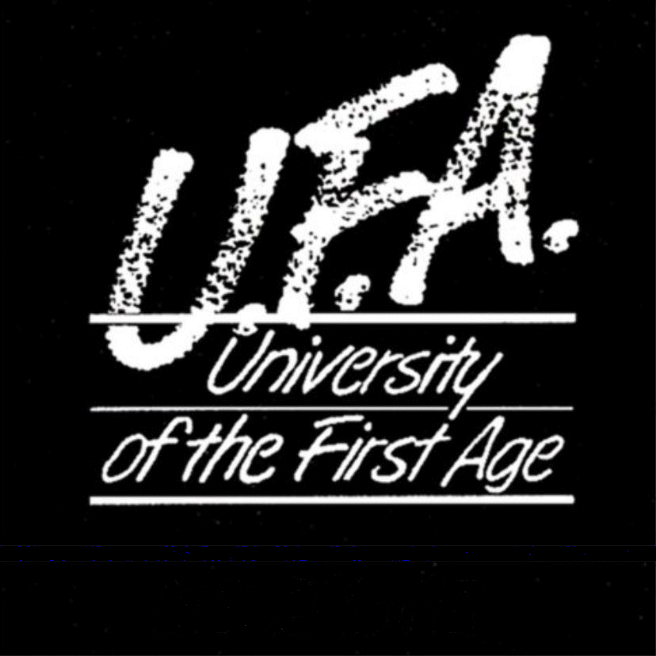







Headteacher

