
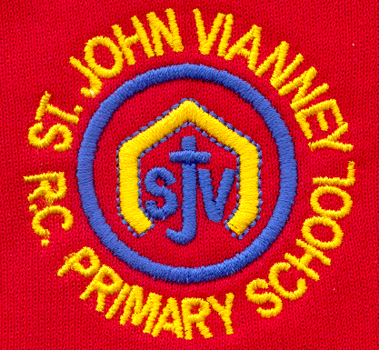

Hillhead Road
West Denton
Newcastle upon Tyne
NE5 1DN
Telephone: 0191 2672233
Fax: 0191 2679538
admin@stjohnvianney.newcastle.sch.uk
www.stjohnvianney.newcastle.sch.uk

Mr A M Duffy
Headteacher
St. John Vianney Catholic Primary School
©

15th November, 2019
Dear Parents and Carers,
Year 1 Liturgy
Thank you to everyone who came along to Mrs Langford and Mrs Dunsford’s Year 1 Class Liturgy on Wednesday morning. It really was a wonderful occasion where children and their families celebrated God’s wonderful world and the importance of saying thanks to God for everything that we have. Thank you to everyone involved and to our wonderful children.

Christmas Dinner
Christmas Dinner Day is Wednesday 4th December. If your child has packed lunch and they would like a Christmas dinner, please return the attached form before Friday 22nd November 2019.

Home-School Reading Books
Great news! Most of our new home-school Reading books have arrived in school and they have now been catalogued into our Home-School Reading scheme. We will send these out next week. Please be aware that we have reorganised our books, particularly the home-school Reading books in Early Years and Key Stage 1, to match more closely the order of sounds that we are teaching in class. Whilst we do not anticipate any teething problems with this new system, please bear with us if your child brings home a book that they have already brought home. The key message from OFSTED (September 2019) is that children should be re-reading books at least three times to develop their fluency in Reading so any additional reading of a text that they are familiar with is clearly excellent practise! We know that our continual investment in Reading will only strengthen even further the provision we are able to offer our children here at St. John Vianney.

Children In Need – Friday 15th November
Thank you to everyone who has donated money to Children In Need today and for your generosity. It is very much appreciated.

Congratulations on your Retirement Mrs Tait!
Mrs Tait has retired from her role in school as a Classroom Teaching Assistant but she is still a Lunchtime Supervisory Assistant with us. I would like to take this opportunity to thank Mrs Tait for everything that she has done to help and support the children of our school and wish her every happiness in her Retirement.

Bikeability
This week, our Year 6 children have taken part in a two-day Bikeability course. I am delighted to inform you that all of our children in Year 6 can now confidently ride a bike. Despite the cold weather, the children have thrown themselves into their Cycling Proficiency and I was extremely proud of the effort and enthusiasm shown by every single one of them. Well done Year 6!

Yours sincerely,
Mr A M Duffy









Headteacher

