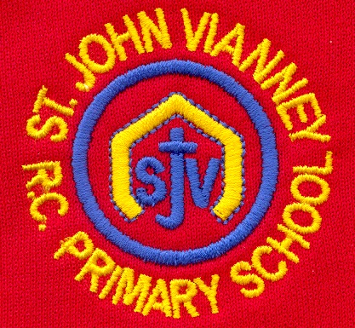

**PSHE**

Health and Wellbeing; Relationships; Living in the Wider World

**Music**

Children will begin to understand pitch on the stave. They will play with their voices to allow an understanding of intervals and how they correspond to written notation. Children will listen to, and analyse, live and recorded music making sure to utilise complex vocabulary and well thought through opinions. Children will study some of the Great Composers.

**History**

***World War Two (continued):*** key events; key figures; causes; propaganda; children in the war; the Blitz; evacuation; effects; analysing sources.

**Art and Design Technology**

Making Memories – Creating sculpture and 3D.

**French**

To say how you come to school; infinitive form of the verb; begin to conjugate regular present tense -er verbs; ask and answer questions; revise numbers 1-40; school subjects.

**P.E.**

***Gymnastics:*** gymnastic sequences; using balance; travel; speed; positioning.

**Dance:** Partner, individual and group dances.

**Mathematics**

***Percentages:*** Finding the percentage of a number; finding the percentage of a quantity; finding percentage change, using percentages to compare.

***Measurement***: Converting units (metric and imperial units); finding the area and perimeter of shapes (rectangles, parallelogram and triangles).

***Ratio and Proportion:*** to use ratios and fractions to compare objects; to find the relationship between ratios, percentages and fractions; to compare numbers using ratios; to make decisions about simplifying ratios using division.

***Geometry and Statistics:*** Position & direction; properties of shapes; angles.

***Position and Direction:*** coordinates on all four quadrants; translation and reflection; compass points.

***Algebra:*** formulae; linear number sequences; missing numbers; pairs of numbers to satisfy equations; finding all possible solutions.

***Statistics:*** pie charts; drawing and interpreting graphs; miles to km; mean as an average; Venn and Carroll diagrams.

**Religious Education**

**Local Church: Sources**

The Bible and its books and authors

**Eucharist: Relating – Unity**

The Eucharist challenges and enables the Christian family to live and grow in communion every day

**Lent: Easter**

The Church’s seasons of Lent, Holy Week and Easter; the suffering, death and resurrection of Jesus led to newlife

**Other Faiths: Islam**

Guidance for Muslims: The 5 Pillars and Zakat

**Science**

***Light:*** Light sources; shadows; how light travels;using mirrors; different materials and light; practical investigations.

***Electricity:*** what is electricity;electrical circuits; electrical resistance; testing circuits; practical investigations.

**English**

***‘The Diary of Anne Frank’:*** Biography and autobiography.

***‘Letters From The Lighthouse’ by Emma Carroll:*** Diary entry; Letter; Newspaper article; Persuasive speech; narrative.

***Alma:*** Creating suspense Narrative Writing

***Grammar:*** revision of Autumn Term grammar; parenthesis; subjunctive form; prefixes/suffixes; hyphens; apostrophes; conjunctions; semi-colons; tenses.

**Computing**

***Programming:*** introducing variables; variables in programming; improving a game; designing a game; design to code; improving and sharing***.***

**Year Six – Spring Term**