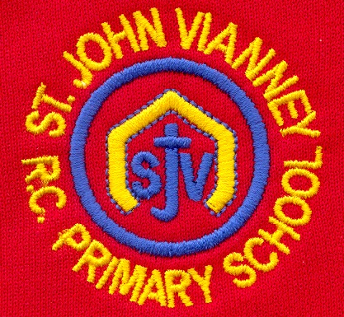

**French**

Children will be able to talk about how old they are and where they live. They will also be able to give a spoken and written description of places.

**Music**

Children will compose music using crotchets and quavers and simple sight reading. They will use guitar, keyboard and drums to write and play as part of an ensemble.

**Religious Education**

**Energy:**

The children will explore the energy of fire and wind. They will discuss the wonder and power of the Holy Spirit and they will reflect on the story of Pentecost, where the disciples were filled with the Holy Spirit.

**Choices:**

Through this topic, we will explore choices and their consequences. Children will understand more fully the Sacrament of Reconciliation.

**Special Places:**

The children will identify that the Christian community has many special places: places where people gather for prayer and worship. They will learn that these places are holy because of their association with Jesus or holy people and that they are places of pilgrimage.

**Other Faiths: Islam**

The Mosque is the Muslim place of worship.

**Mathematics**

**Multiplication and Division** Children will consolidate their knowledge of times tables.

**Money** Adding and subtracting money and calculating change.

**Time** Telling the time and measuring time in seconds, minutes and hours. Converting minutes to seconds and seconds to minutes.

**Pictograms and Bar Graphs** Drawing and interpreting pictograms and bar graphs.

**History**

Children will understand who the Ancient Egyptians were and what their major achievements were. They will understand where this period sat in relation to other key historical events and they will also examine what happened during this era.

**P.E.**

Children will gain an understanding of fundamental athletic skills to develop technique, control and balance of their bodies. They will also take part in guided Dance group routines.

**Art**

Children will study Egyptian Art and they will make their own Egyptian scrolls.

**Geography**

**Changing Jobs**

Children will learn about different jobs and the job sectors they belong to. Through analyzing pie charts, they will compare job sectors with different countries and explore how these sectors may change in the future.

**Science**

In our **Forces** topic, children will learn about contact and non-contact forces and investigate magnetic forces. In our **Light** topic, children will be investigating light sources, shadows and the apparent movement of the sun.

**Year Three – Summer Term**

**Computing**

Children will create programs with sequencing, loops and events. They will investigate problem-solving techniques and develop strategies for building positive communities both online and offline.

**English**

**Non-Fiction Text *– Diary Writing***

Children will write their own Diary entry on the excavation of Tutankhamun.

**Mystery and Adventure Stories**

***Taking Flight***

Children will read and understand the features of these texts and they will create their own story using the *Story Mountain* writing frame. Children will write an Extended Narrative based on the digital literacy clip.

**Performance Poetry**

***“Revolting Rhymes” by Roald Dahl***

Children will explore rhyming couplets. They will read, write and perform a range of poems. They will explore features such as similes, metaphor, alliteration and rhyme.

**Grammar:** Children will learn to use coordinating and subordinating conjunctions, adverbs, pronouns and apostrophes accurately in their writing,

**Handwriting:** Children will continue to use the diagonal and horizontal strokes needed to joinletters.

**PSHE**

Health and Wellbeing; Relationships; Living in the Wider World.