


Hillhead Road
West Denton
Newcastle upon Tyne
NE5 1DN
Telephone: 0191 2672233
Fax: 0191 2679538
admin@stjohnvianney.newcastle.sch.uk
www.stjohnvianney.newcastle.sch.uk

Mr A M Duffy
Headteacher
St. John Vianney Catholic Primary School
©

20th March 2020

Dear Parents and Carers,

In response to the new government guidelines which were released this morning, I can now offer the following advice, and hopefully some further clarity.
All other schools were closed from the end of the school day today. The government has asked parents to keep their children at home wherever possible and asked schools to provide for those who absolutely need it.
Advice states that in order to reduce the spread of the virus, we can only offer places to a limited number of children. Childcare therefore, may need to be allocated on a priority basis. Initial guidance indicates that this should be a maximum of 20% of the school population. I hope you appreciate that difficult decisions may need to be made.
It is clear from government advice that if it is at all possible for children to stay at home, then they should, to limit the chance of the virus spreading. We ask that you please follow this advice and do not request a childcare place unless it is absolutely necessary.
Priority will be given to those who are working tirelessly to stop the spread of this virus, administering essential medical care and keeping our country safely running.
If you are able to safely sort childcare, or you are working from home, please try to utilise all other means before sending children to school.
We will operate with a minimum number of staff for as long as we can safely do so to enable us to care for the children who need to attend. Your children will therefore not have the same teacher each day.
During this period of school closures, we will not be operating normal lessons. If we do have children in school, we will be doing similar home learning activities to those that we have set for all other children. No other teaching will be taking place so as not to disadvantage the vast majority of children who have been told they must stay at home.
If you do need a childcare place and fit the criteria of being a Key Worker, please refer to the information on our website under the ‘Key Worker and Vulnerable Children Criteria’ section in order that we can make informed decisions.
Yours sincerely,

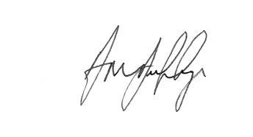

Mr A M Duffy
Headteacher













