
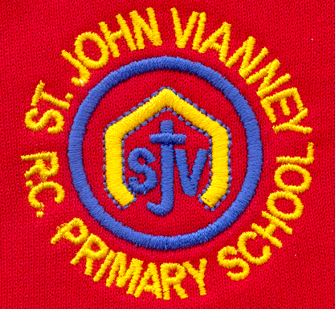

Hillhead Road
West Denton
Newcastle upon Tyne
NE5 1DN
Telephone: 0191 2672233
Fax: 0191 2679538
admin@stjohnvianney.newcastle.sch.uk
www.stjohnvianney.newcastle.sch.uk

Mr A M Duffy
Headteacher
St. John Vianney Catholic Primary School
©

2nd October, 2020

Dear Families,

Home-School Reading
As we informed you earlier in the term, we have purchased Oxford Reading Tree E-Book Library to give your child access to online Reading at home. This will give your child access to 550 books online. We have also signed up to an online home-school Reading system with Oxford Reading Tree. Unfortunately, however, the launch of this has been delayed nationally until January due to technical difficulties with the programme. We have therefore taken the decision to send home our home-school Reading books from school in the interim.

Your child will bring home their Reading book on a Friday and these should be returned on a Monday so that they can be quarantined for 72 hours before putting them back into our home-school Reading library. Your child’s class teacher will have a separate Reading Record book for your child that they will fill in every time they read with your child during individual, group and guided reading sessions in school. We are still employing the same system whereby your child will read the same book three times in order to develop their Reading fluency in light of OFSTED guidance and general good practice in the teaching and learning of Reading.

Can we please ask that you sign your child’s home-school Reading record and make any comments that you feel are relevant for your child’s class teacher as these are greatly appreciated and provide us with an insight as to how your child is reading at home.
Thank you for your support with Reading, it is, as always, very much appreciated.

IXL Homework
From this weekend, your child’s teacher will allocate weekly Maths and English homework to be completed through the online IXL programme.

To access this, your child will need to log on to IXL through the school website under the Home Learning section and their year group. Once they type in their username and password (advice is provided in the Home Learning section), there will be a pop up box appears with Class Teacher skills. Your child will need to complete these activities for the following Wednesday. Every class teacher has online access so they can see how pupils have managed the tasks and further support that they may need.

Your child will also bring home their spellings for the half-term. All spellings will be tested on a Friday in the usual way. By providing you with the spellings for the remainder of this half-term, we aim to give our children as much time as possible to learn their spellings securely.

Thank You
Can I personally thank you for supporting all of our new systems and routines in school. Your co-operation in all of these measures is crucial and greatly appreciated. Please continue to exercise social distancing when you are waiting to drop off and collect your child, as cases are rising rapidly across the city.

Gosforth Park First School
I am sure that many of you will be aware of the serious incident that occurred at Gosforth Park First school last Friday afternoon.
On behalf of everyone at St. John Vianney school, I offer our deepest sympathy and prayers to the family, friends and the whole of the Gosforth Park school community at this terribly difficult time.

Thank you, once again, for your patience, understanding and co-operation in these challenging times.

With my very best wishes,

C.Meldrum

Acting Headteacher

