


Hillhead Road
West Denton
Newcastle upon Tyne
NE5 1DN
Telephone: 0191 2672233
Fax: 0191 2679538
admin@stjohnvianney.newcastle.sch.uk
www.stjohnvianney.newcastle.sch.uk

Mr A M Duffy
Headteacher
St. John Vianney Catholic Primary School
©

5th September 2019

Dear Parents of Year 3 – (Mr Galley’s Class)

Swimming takes place this term for Year 3 commencing Monday 9th September 2019. The children will walk to and from Denton Pool, West Denton.

Your child will need his/her swimming costume in school each Monday until the end of term.

Girls: Full costume, no bikinis, swimming caps for long hair.

Boys: Swimming trunks (above the knee), no Bermuda shorts, optional cap.

Goggles optional.

Each child will need a towel, a bag to carry kit back and forward.

Yours sincerely,

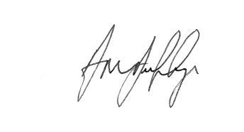

Mr A M Duffy
Headteacher













