
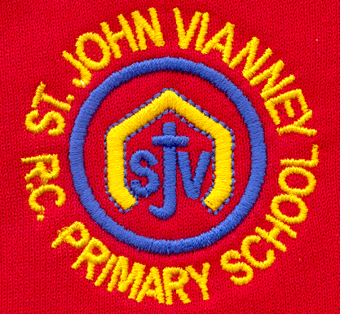

Hillhead Road
West Denton
Newcastle upon Tyne
NE5 1DN
Telephone: 0191 2672233
Fax: 0191 2679538
admin@stjohnvianney.newcastle.sch.uk
www.stjohnvianney.newcastle.sch.uk

Mr A M Duffy
Headteacher
St. John Vianney Catholic Primary School
©

4th September, 2020

Dear Families,

Welcome Back
Welcome to the first edition of our Friday Newsletter for this academic year.

On behalf of all the Governors and Staff at St. John Vianney Primary school, I extend a warm welcome back to you all. We are really looking forward to welcoming all of our children back to school on Tuesday 8th September. I also extend a very warm welcome to Mrs Driver, who will be working as a Classroom Teaching Assistant with Mrs Lake and Mrs Sibbet in Nursery, Miss White, who will be working with Mrs Langford, Mrs McLean and Mrs O’Donnell in Year 1, Mrs Young, who will be working as a Classroom Teaching Assistant in Year 3 and Year 5 and Miss Allen, who will be working as a Classroom Teaching Assistant with Mr Peacock and Miss Prayle in Year 4. I am also delighted to welcome our Nursery children and Reception children who will be starting our school next week and we hope that they will all settle quickly and feel a part of our school community.

I would also like to wish all of our Year 6 pupils, who left St. John Vianney school in July, the very best of luck as they begin their new Secondary schools next week. They were a wonderful Year 6 cohort and an absolute asset to themselves, their families and St. John Vianney school and we know that they will continue to shine at their new schools. We send every good wish to them as they embark on the next stage of their academic journey.

New Drop-off and Pick-up Procedures
Over the summer, we have had new markings on the path, which are socially distanced in line with Government guidance. These will indicate where children will stand when they line up on a morning. Siblings should stand next to their brother/sister when they line up. Your child’s class teacher will walk their line into school and a designated member of staff will take siblings to their classes. Thank you in advance for your patience and co-operation with the new procedures in place.

The new Upper Key Stage 2 Block – The Lindisfarne Suite

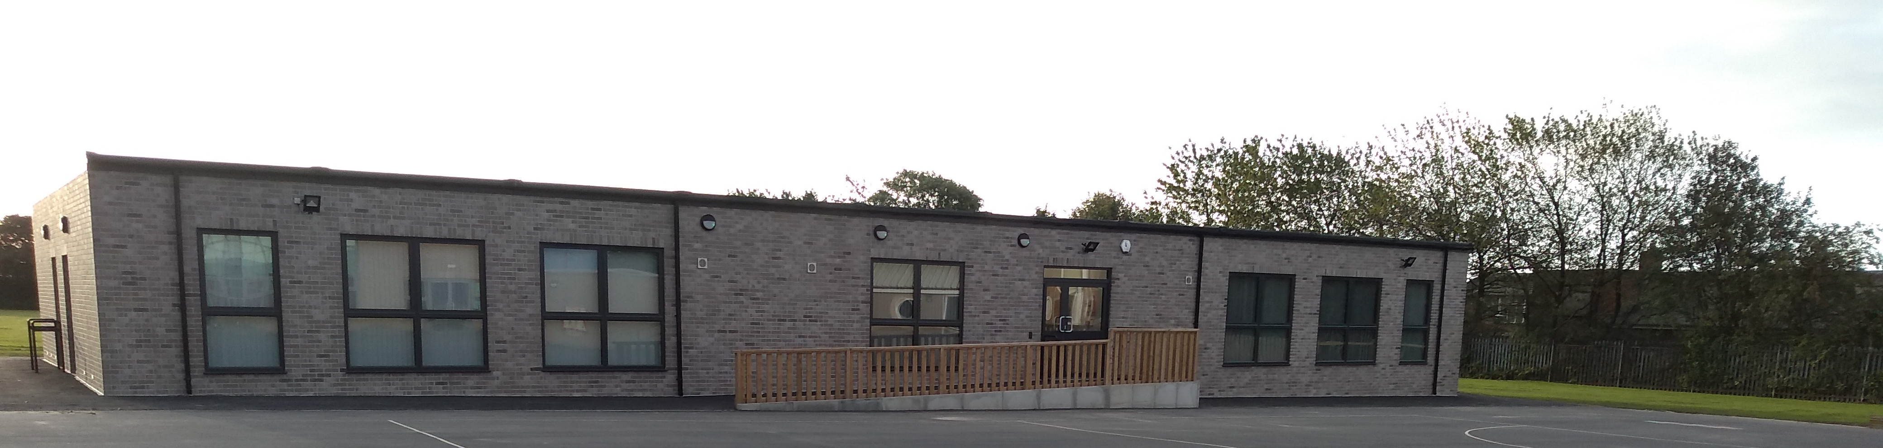
I am delighted to announce the completion of the new Upper Key Stage 2 Block, which has been named ‘The Lindisfarne Suite’. As you can see from the picture, this is a very impressive building, which enhances even further the teaching space here at our school.
It is wonderful that Mr Duffy, who has been instrumental in this and indeed in all of the building work in school, was here to see the completion of the final phase of building work, which now takes our school to a fully-operational two-form entry school. I know you will join me in wishing Mr Duffy a wonderful and very well-earned Retirement.

Going Back to School
We have added some resources on our website, aimed at supporting children in their transition back to school, which you may find useful. You can find these resources on our website under the heading, Coronavirus then Useful Resources for Going Back to School.

Thank you again for your patience, understanding and co-operation in these challenging times and we look forward to seeing you all on Tuesday 8th September.

Yours sincerely,

C.Meldrum

Acting Headteacher

