
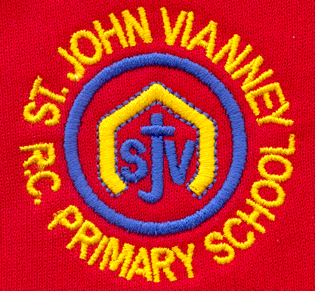

Hillhead Road
West Denton
Newcastle upon Tyne
NE5 1DN
Telephone: 0191 2672233
Fax: 0191 2679538
admin@stjohnvianney.newcastle.sch.uk
www.stjohnvianney.newcastle.sch.uk

Mr A M Duffy
Headteacher
St. John Vianney Catholic Primary School
©

29th March, 2019
Dear Parents and Carers,

Year 1 Liturgy
Mrs McLean’s Year 1 class led their parents/carers and friends in a beautiful Liturgy about Lent on Wednesday. Their singing and reading was absolutely fantastic. Well done Year 1!

Mini Vinnie’s Easter Egg Raffle
From Monday, our Mini Vinnies will be selling raffle tickets for an Easter Egg Raffle that will be drawn on Thursday 18th April.
The Mini Vinnies will visit each class every day so anyone wishing to buy a strip of raffle tickets (costing £1.00 per strip) should send money into school via their child’s class teacher.
Any donations of Easter Eggs would also be gratefully received. All money raised will be donated to CAFOD. Thank you in advance for your support.

Bishop Robert Byrne’s Welcome Mass
On Tuesday afternoon, two children and I went to Bishop Robert Byrne’s Welcome Service at St. Mary’s Cathedral. We were one of 156 schools who attended this celebration. It was a wonderful occasion as we welcomed our new Bishop into our Diocese.

Reception Trip to the Farm
On Wednesday, both of our Reception classes went to Hall Hill Farm. A fabulous day was had by all! All photographs taken will be uploaded onto our school website so please take a look.

Science Week
Next week, we have a very exciting Science Week planned in school with some wonderful workshops and activities led by Scientists, our staff and our High School colleagues. We will record our week on the next edition of @ The School Gate and we will upload photographs onto our website as soon as we have taken them. What a fun-filled week we have in store!

After-School Clubs
Next week is the last week for after-school clubs this half-term.

Dance Festival
Next Wednesday, our Year 5 children will be travelling to the City Hall to take part in the city’s Dance Festival. Our children have been practising extremely hard with our dance choreographer and I know they are going to be amazing. Enjoy the show Year 5, we are very proud of you.

Easter Holidays
We have had another very busy term in school and we look forward to an exciting last week. We break up for the Easter holidays next Friday, 5th April, and I look forward to welcoming you all back to school on Monday 15th April.

Thank you for your continued support of our school.

Yours sincerely,
Mrs C Meldrum
Acting Headteacher











