
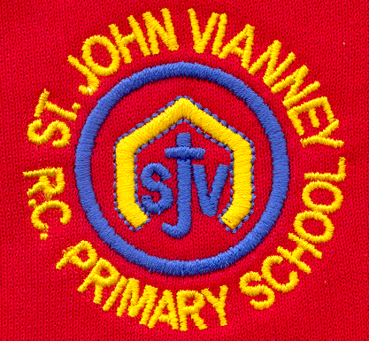

Hillhead Road
West Denton
Newcastle upon Tyne
NE5 1DN
Telephone: 0191 2672233
Fax: 0191 2679538
admin@stjohnvianney.newcastle.sch.uk
www.stjohnvianney.newcastle.sch.uk

Mr A M Duffy
Headteacher
St. John Vianney Catholic Primary School
©

11th January, 2019
Dear Parents and Carers,
Happy New Year!
I would like to welcome you all back to school and wish you all a very Happy New Year. I hope you had a wonderful holiday and that the children are refreshed and ready for another hard-working term in school.

Healthy Schools Award
I am delighted to inform you that we have been awarded the Healthy Schools Award once again. This is a huge achievement and rightly recognises all of the hard work that we do in school to promote healthy living. I must thank Mr Bonnar, who is our Healthy Schools Co-ordinator in school, and you, our parents and carers, for supporting us in our work and sending healthy packed lunches into school. Well done St. John Vianney!

Year 4 Liturgy
We would like to invite the parents, carers and friends of Mr Bonnar’s Year 4 class to their Class Liturgy on Wednesday 16th January at 9.15am in the school hall. We look forward to seeing you there.

Year 4 First Reconciliation
Year 4 will make their Sacrament of Reconciliation on Thursday 17th January at 5.00pm in St. John Vianney church. The children have been working very hard with Miss Elliott, Mr Bonnar and Mr Peacock in preparation for this as they journey towards making their First Holy Communion in May.

Reception Request
This term, Reception class are learning about people who help us particularly people in the emergency services – police, fire brigade and ambulance service. They would be very grateful for any donations of emergency service vehicles, costumes, jigsaws, books and small world toys. All donations will be greatly appreciated. Thank you in advance.

Yours sincerely,
Mr A M Duffy

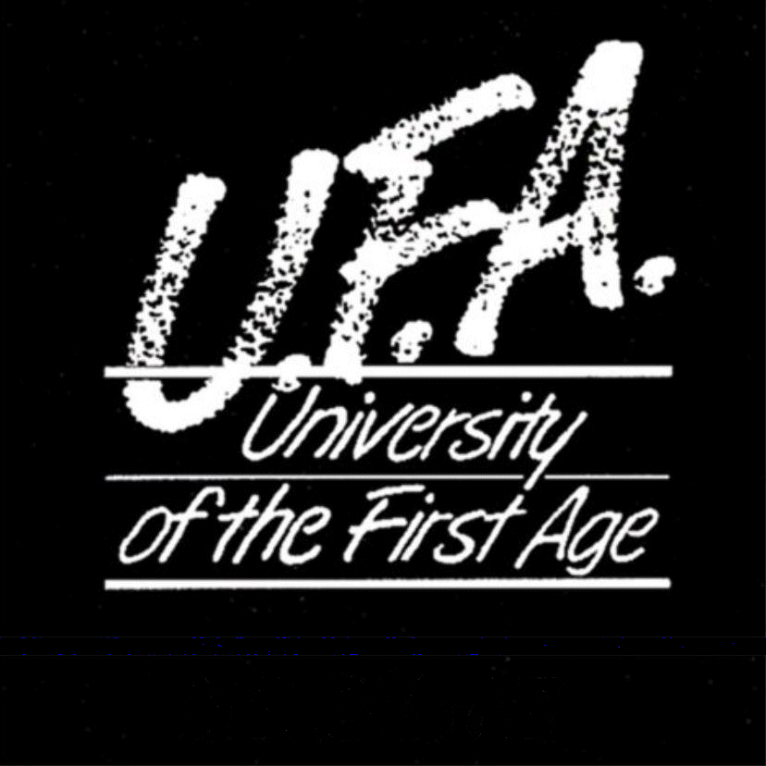







Headteacher

