
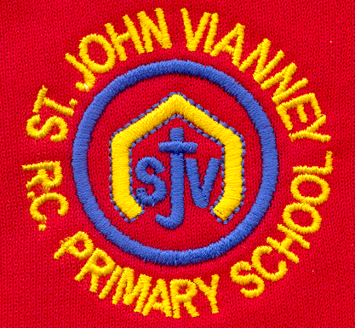

Hillhead Road
West Denton
Newcastle upon Tyne
NE5 1DN
Telephone: 0191 2672233
Fax: 0191 2679538
admin@stjohnvianney.newcastle.sch.uk
www.stjohnvianney.newcastle.sch.uk

Mrs A Thorpe
Headteacher
St. John Vianney Catholic Primary School
©

5th March 2021

To the families of children in the Year 5 Bubble,

As you will be aware, we have worked very hard in order to ensure that our school is a Covid-secure and safe place for our pupils and our staff.

We have carefully followed all of the public health advice and guidance, and have carried out an in-depth risk assessment in order to put in place measures to minimise the risk of the virus spreading. This risk assessment is regularly reviewed as guidance is updated.

However, while the virus remains with wider society – and with cases in our area now rising – it is perhaps to be expected that we will experience some cases within our school community.

This morning, we have been informed that someone in the Year 5 bubble has tested positive for COVID-19. We continue to work closely with Public Health England and the Local Authority, to ensure everyone is as safe as possible and all self-isolation guidance is accurate.

Year 5 Key Worker and Vulnerable Pupils will therefore need to self-isolate for 10 days from Tuesday, which will mean a return to school on Monday 15th March 2021. All other Year 5 pupils who have not attended school last week can return to school on Monday 8th March.

We are sorry that we have to take this step and we understand that this will cause inconvenience for many of you.

However, at this time, we have no choice but to take this action to ensure the safety of staff and pupils while they are in school in line with Public Health England guidance.

If your child is eligible for a Free School Meal, a supermarket voucher will be ordered for you, and a redeemable code sent to your mobile phone.

Other members of your household can continue normal activities provided your child does not develop symptoms.

What to do if your child develops symptoms of COVID-19
The most common symptoms of COVID-19 are:
• New continuous cough and/or
• High temperature and/or
• A loss of, or change in, normal sense of taste or smell

If your child develops any of these symptoms, they should remain at home and arrangements should be made for them to be tested by ringing 119 or visiting the NHS website: nhs.uk/coronavirus. At that time, all other household members must also stay at home and not go to work, school or public areas even for exercise.

Please visit the Home Learning section of our school website for activities set by class teachers.

We thank you for your ongoing support and we will continue to keep you informed and up-to-date with any new information.

Best wishes,

A D Thorpe

Mrs A. D. Thorpe
Head teacher

