
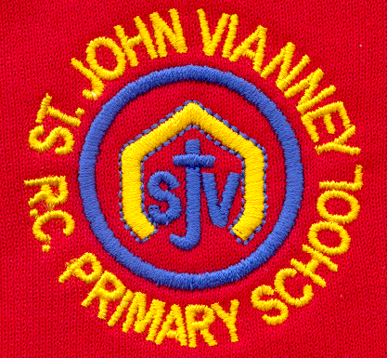

Hillhead Road
West Denton
Newcastle upon Tyne
NE5 1DN
Telephone: 0191 2672233
Fax: 0191 2679538
admin@stjohnvianney.newcastle.sch.uk
www.stjohnvianney.newcastle.sch.uk

Mr A M Duffy
Headteacher
St. John Vianney Catholic Primary School
©

30th September, 2020

To the Families of children in Year 4,

INSTRUCTION FOR ALL YEAR 4 CHILDREN

Following guidance from Public Health England, all pupils in Year 4 are currently self-isolating for 14 days.

In line with national guidance, all Year 4 pupils can return to school on Monday 5th October providing they are well at the end of the period of self-isolation.

What to do if your child develops symptoms of COVID-19
The most common symptoms of COVID-19 are:
- New continuous cough and/or
- High temperature and/or
- A loss of, or change in, normal sense of taste or smell

If your child develops any of these symptoms, they should remain at home and arrangements should be made for them to be tested by ringing 119 or visiting the NHS website: nhs.uk/coronavirus. At that time, all other household members must also stay at home and not go to work, school or public areas even for exercise.

Can I thank you, once again, for your ongoing support and co-operation during these challenging times.

With my very best wishes,
Mrs Meldrum
Acting Headteacher

