
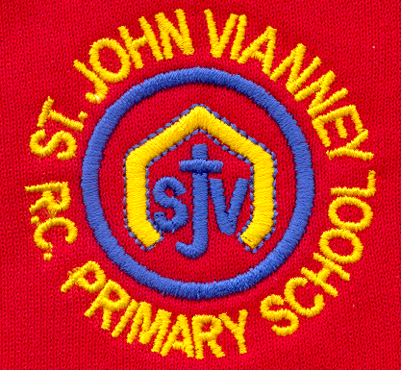

Hillhead Road
West Denton
Newcastle upon Tyne
NE5 1DN
Telephone: 0191 2672233
Fax: 0191 2679538
admin@stjohnvianney.newcastle.sch.uk
www.stjohnvianney.newcastle.sch.uk

Mr A M Duffy
Headteacher
St. John Vianney Catholic Primary School
©

25th January, 2019
Dear Parents and Carers,

Board Games and Books Request
I would like to say a big thank you to everyone who has donated board games and books to school so far. They have been very well received. If anyone is having a clear out after Christmas and has any spare board games or books that they wish to donate, we are still willingly accepting donations. All donations should be brought into school via your child’s class teacher for the attention of Mrs Meldrum. Thank you.

Year 4 Class Liturgy
Mr Peacock’s Year 4 class would like to invite their parents, carers and friends to their Class Liturgy next Wednesday (30th January) at 9.15am in the school hall. The theme of their Liturgy is Building Bridges and we look forward to our Year 4 children leading the community in a special Liturgy then.

Requests
Can I please ask that you make sure that your child’s uniform is clearly labelled with their name. I’m sure you can appreciate how difficult it is for children to identify their clothing after PE without their name in and we have a growing pile of lost property already.
Can I also please remind you that dinner money should be brought into school on a Monday (if school dinners are not paid through our online system) as it is collected by Newcastle City Council on Monday afternoon. Thank you for your support in this matter.

We have had a wonderful start to the new year and I thank you all for your continued support of our school.

Yours sincerely,
Mr A M Duffy
Headteacher











