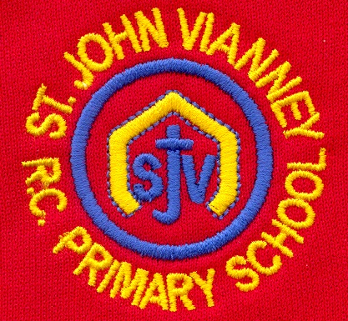

**Science**

**Forces**

* Explain that unsupported objects fall towards earth because of the force of gravity acting between the Earth and the falling object.
* Identify the effects of air resistance, water resitance and friction, that act between moving surfaces.
* Recognise that some mechanisms including levers, pulleys and gears allow a smaller force to have a greater effect.

**Animals (including humans)**

* describe the changes as humans develop to old age.

**Year Five – Summer Term**

**English**

***Macbeth by William Shakespeare***

*Drama; playscript; character description; setting description.*

**Saving Energy** Debate; discussion text

**Grammar:** Pronouns and possessive pronouns; Subordinate clauses; Homophones; Writing cohesive paragraphs; Parenthesis – brackets, dashes and commas; Adverbials and fronted adverbials; Dictionary work; Relative clauses; Using inverted commas for direct speech

**Reading Vipers:** Explain the meaning of words in context; Make inferences; Predict what might happen in the text; Explain meaning; Retrieve information; Summarise events.

**Computing**

**Computing Systems and Networks**

Systems; computer systems and us; transferring information; working together; better working together, shared working.

**PE**

Swimming, Athletics, Tennis and Rounders

**Mathematics**

**Calculation:** Secure understanding of addition,

subtraction, multiplication, and short division.

**Decimals and Percentages:** Read, write, order,

and compare numbers with up to three decimal

places.Recognise and calculate percentages.

**Measurement:** Solve problems involving measures

using decimal notation.

**Geometry:** Compare, estimate, measure and draw

angles.

**Statistics:** Read and interpret information in line graphs.

**Reasoning and Problem Solving:** Solve multi-step problems in contexts, deciding which operations to use.

**Music**

The children will write music using crotchets, quavers, minims, semi-quavers and more complex time signatures to make their own compositions. They will then perform this as part of an ensemble.

**Religious Education**

**Pentecost - Serving: Transformation**

Celebration of the Spirit’s transforming power.

**Reconciliation - Relating: Building Bridges**

Admitting wrong, being reconciled with God and

each other.

**Universal Church – World: Stewardship**

The church is called to the stewardship of Creation

***Other Faiths:*** **Islam**

Beliefs and festivals – Ramadan and Pilgrimage

**PSHE**

***Health and Wellbeing***

***Living in the Wider World***

***Relationships***

**French**

Learning about saying which sports we play and hobbies we have*. Introducing verbs jouer and faire.*

**Design Technology**

**Soup**

Celebrating culture and seasonality

**Art**

***Design for a purpose***

Coat of arms; Designing spaces; Changing spaces; What’s in a name? Adverts.

**Humanities**

**Energy:** investigate energy use; renewable

energy; non-renewable energy; conserving

energy; sustainability; energy for the future