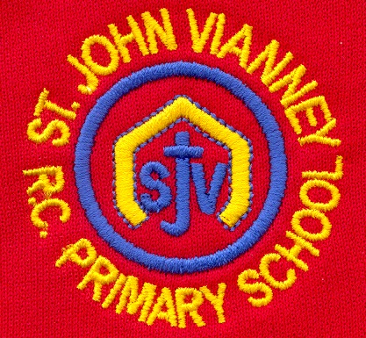

**Computing**

**E-Safety –** sharing online; inappropriate images; online bullying; reporting bullying; pressures of technology

**PE**

**Games:** throwing and catching;

offensive and defensive skills; tactics;

keeping healthy

**French**

Revise classroom language; greetings; revise numbers; questions; ages and dates; days of the week; classroom objects; spelling and phonics; building sentences; making plurals; cultural events

**Design Technology**

**Bread**: history of bread; existing

products; design; making bread;

packaging; evaluation

**Art**

**Exploring art with a message:** ‘Guernica’ by Picasso and Käthe Kollwitz. Develop their drawings to incorporate new surfaces, a range of techniques and demonstrate an emerging personal style

**PSHE**

Health and Wellbeing; Relationships; Living in the Wider World.

**Science**

**Classification**: Classifying living things based on observable characteristics; Carl Linnaeus; microorganisms; fair test

**The Circulatory System**: the heart; heart dissection; blood; the circulatory system; the effects of lifestyle on the heart

**Music**

Musical elements. Composing, performing. Children will learn rhythmic values and sight reading of musical notes. Children will take part in vocal harmonies and choral singing and Musicianship.

**Year Six – Autumn Term**

**English**

**‘Holes’ by Louis Sachar**

Setting; diary entry; letters; discussion;

debate

**Poetry: World War One Poetry**

Context, metaphor; simile; personification

**‘The Nowhere Emporium’ by Ross**

**Mackenzie**

Narrative; dialogue

**The Diary of Anne Frank**

Biography and autobiography

**Grammar**: revision; sentence types and

components; clauses; colons and semicolons; synonyms and antonyms; tenses;

speech punctuation; active/passive voice

**Mathematics**

**Place** **value**: numbers up to 10,000,000;

negative numbers; rounding

**Calculation**: formal written methods of

addition, subtraction, multiplication, short and

long division; problem solving; factors and

multiples

**Fractions, Decimals and Percentages:**

comparing and ordering fractions; addition,

subtraction, multiplication and division of

fractions and decimals; percentages

**Measurement:** millimetres, centimetres, metres, kilometres, converting units of measure; converting units of time

**History**

**Conflict Through Time:** studying conflict, weapons and tactics in prehistoric warfare, ancient warfare (Romans and Greeks), Anglo-Saxon and Vikings, religious wars (The Crusades), modern warfare (WWI and WWII); how has conflict changed through time?

**Geography**

**Hazardous World:** Earth’s structure; tectonic plates; boundary lines; earthquakes; volcanoes; social and economic effects of natural disasters

**Religious Education**

**Loving**

God’s love is unconditional

**Vocation and Commitment**

The Vocation of a Priest

**Advent: Expectations**

Expectations and preparations for the birth

of Jesus Christ

**Other Faiths: Judaism**

Jewish festivals of Yom Kippur and Rosh

Hashanah